MODULE 3 :- Git and GitHub
MANAGING SOURCE CODE – GIT AND GITHUB
SUBMITTED BY :- CHANDAN YADAV KS
SUBMITTED TO :- VIKUL
DATE OF SUBMISSION :- 13-06-2025

1. L1 - Create Local git repository and demonstrate all git reset options and revert. Compare the differences
Step1:- Setup a Local Git Repository
1)Create the file and go inside the file
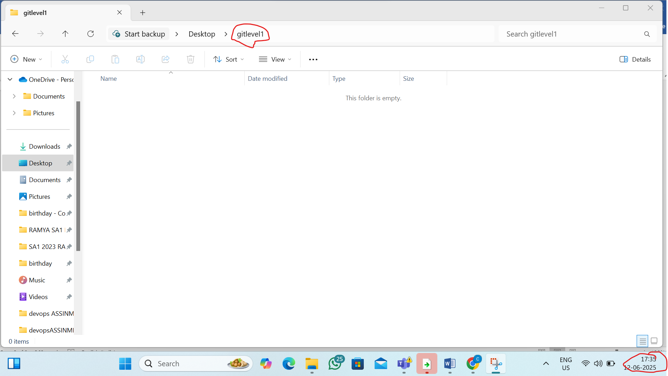
2) STEP2:-from that file open gitbash terminal
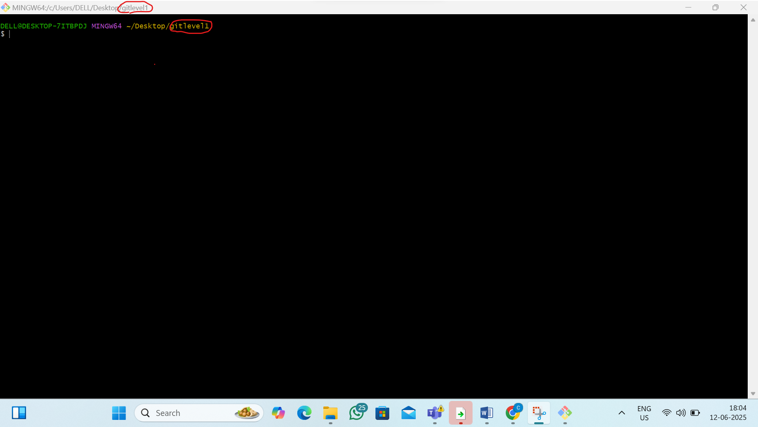

3) Initialize a new Git repository
By the command:- git init
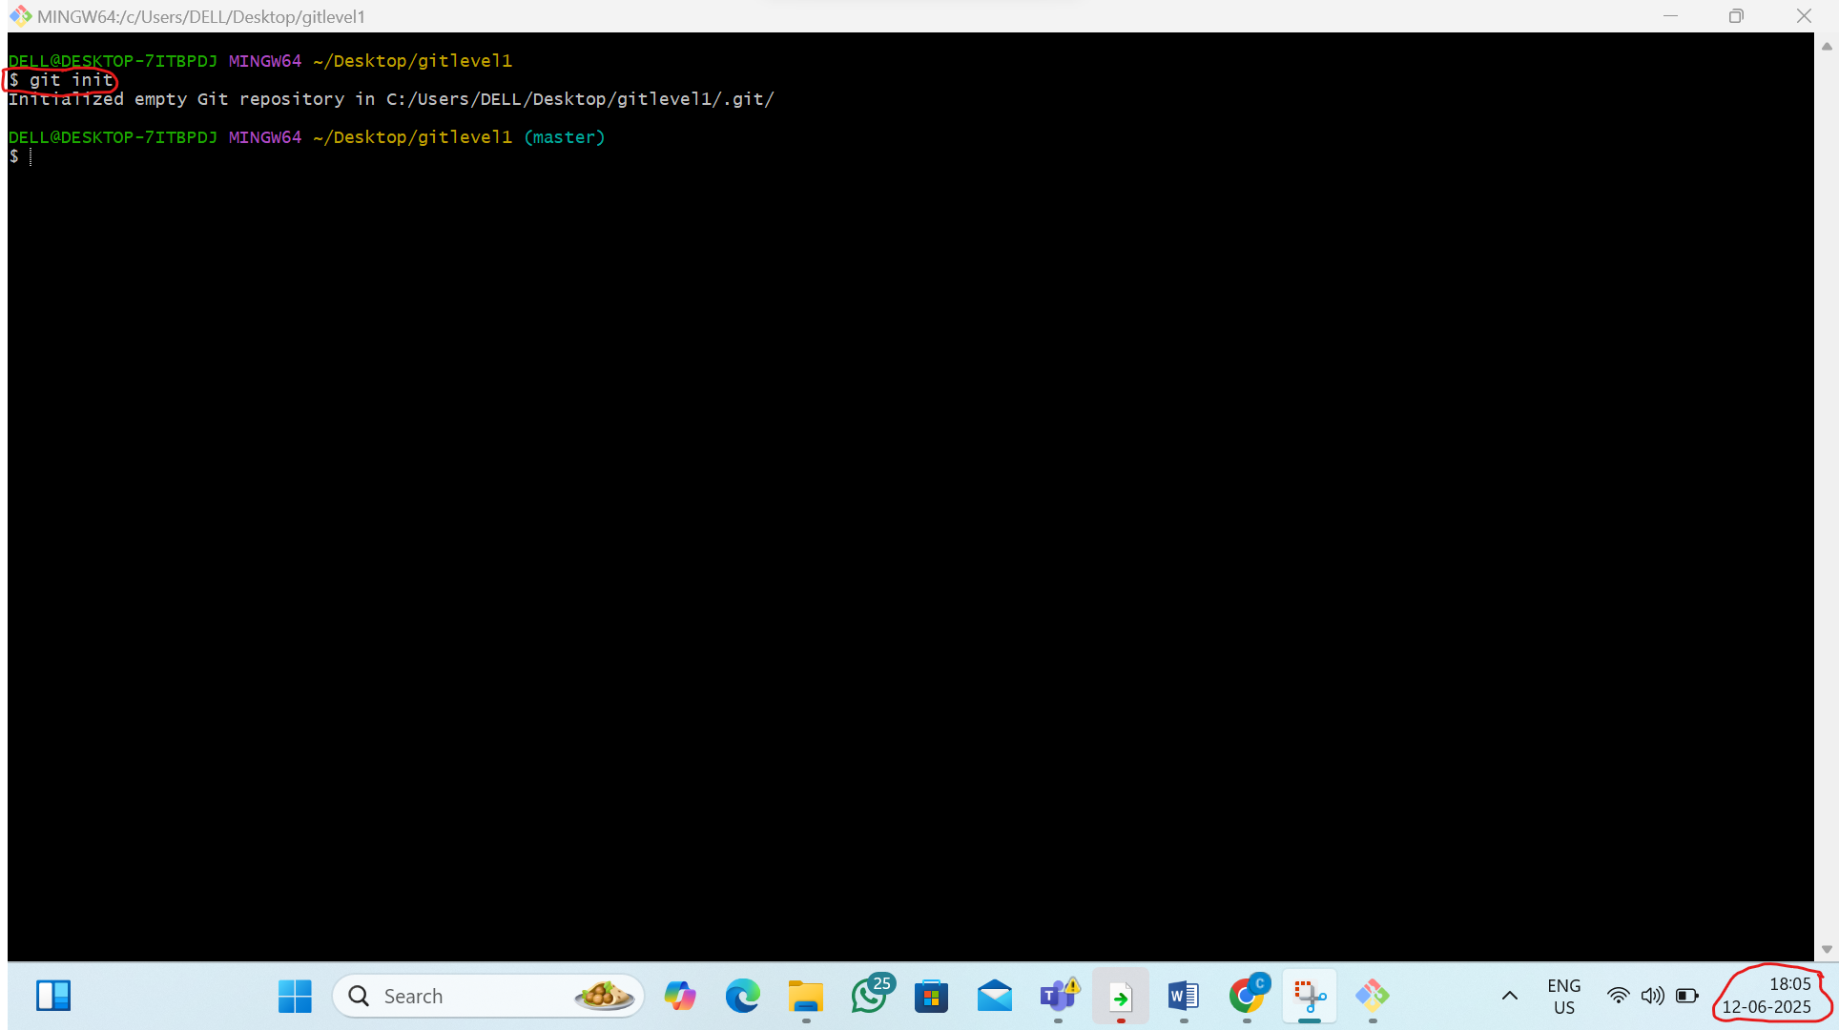
Step 2: Create a 4 Files and Make Some Commits
1)Create file 1
By the command:-1)touch file1.txt,
2)git add file1.txt,
3)git commit -m “c1”
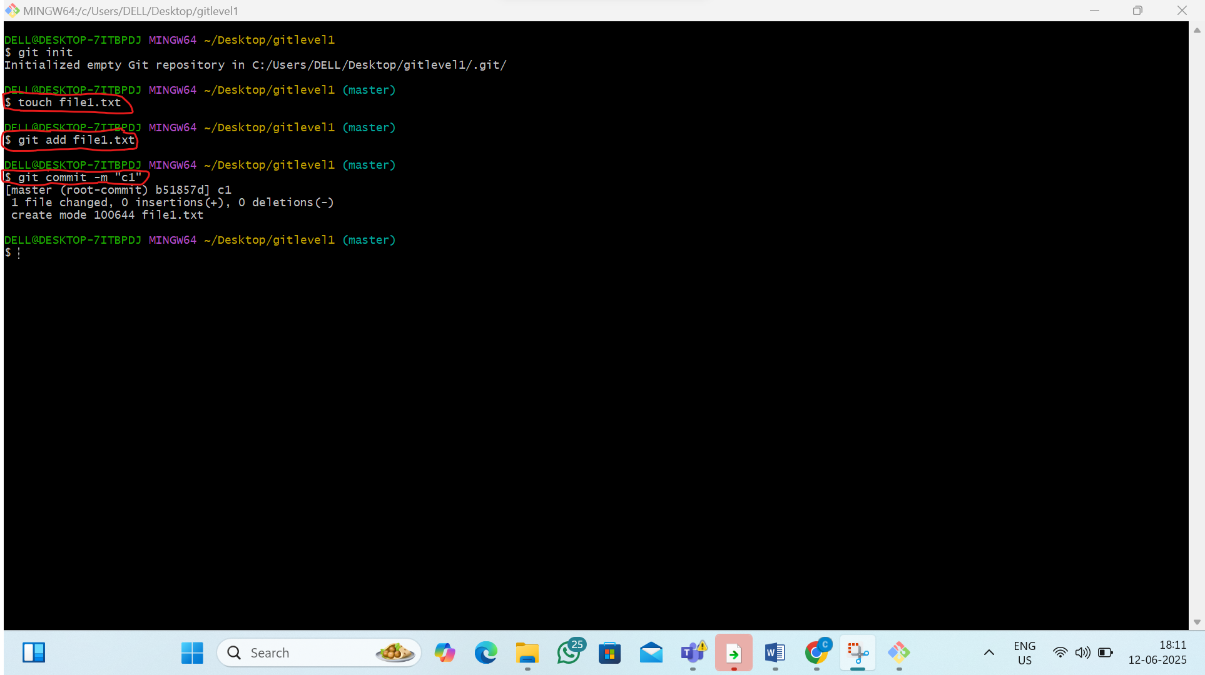
2)Create file 2
By the command:-1)touch file2.txt,
2)git add file2.txt,
3)git commit -m “c2”
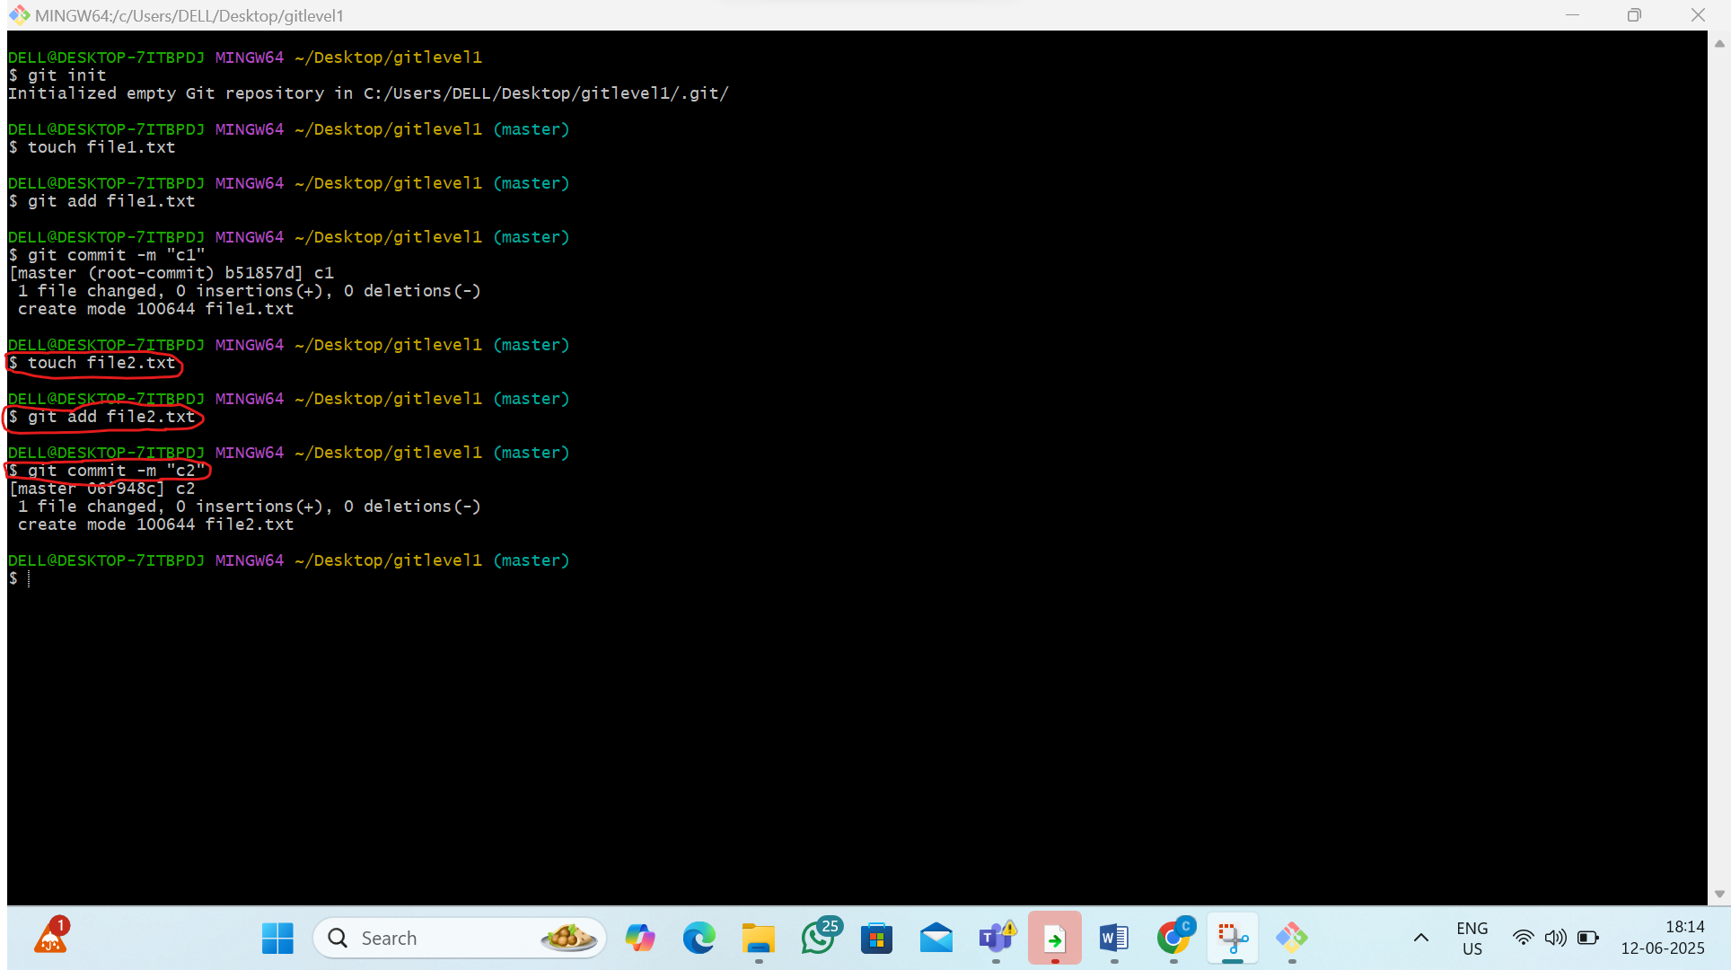
3)Create file 3
By the command:-1)touch file3.txt,
2)git add file3.txt,
3)git commit -m “c3”
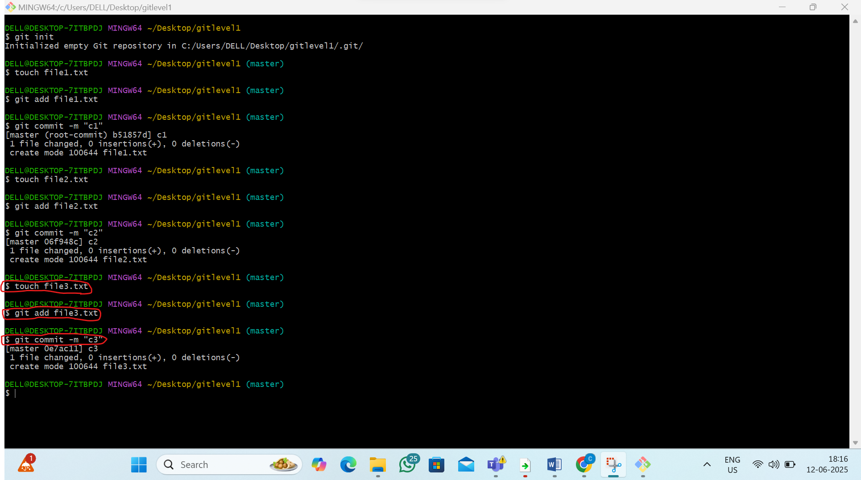
4)Create file 4
By the command:-1)touch file4.txt,
2)git add file4.txt,
3)git commit -m “c4”
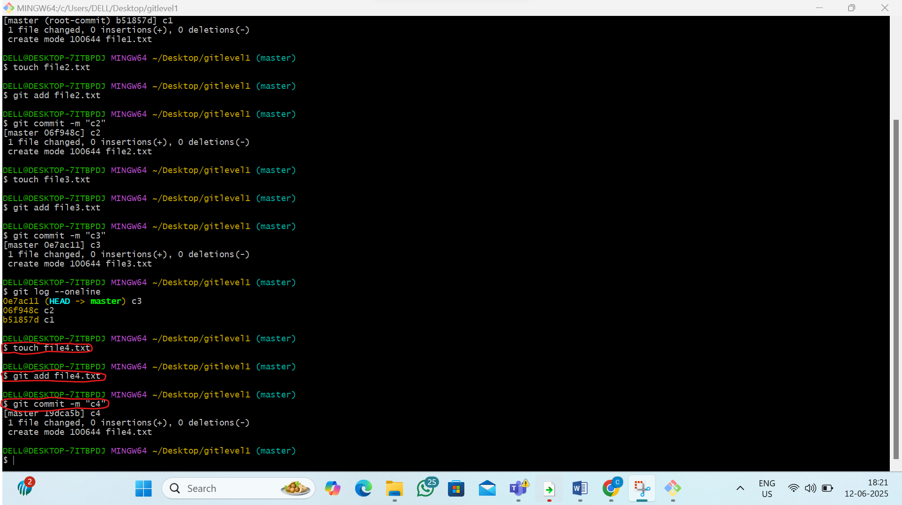
4) check your commit history
By the command:- git log –oneline
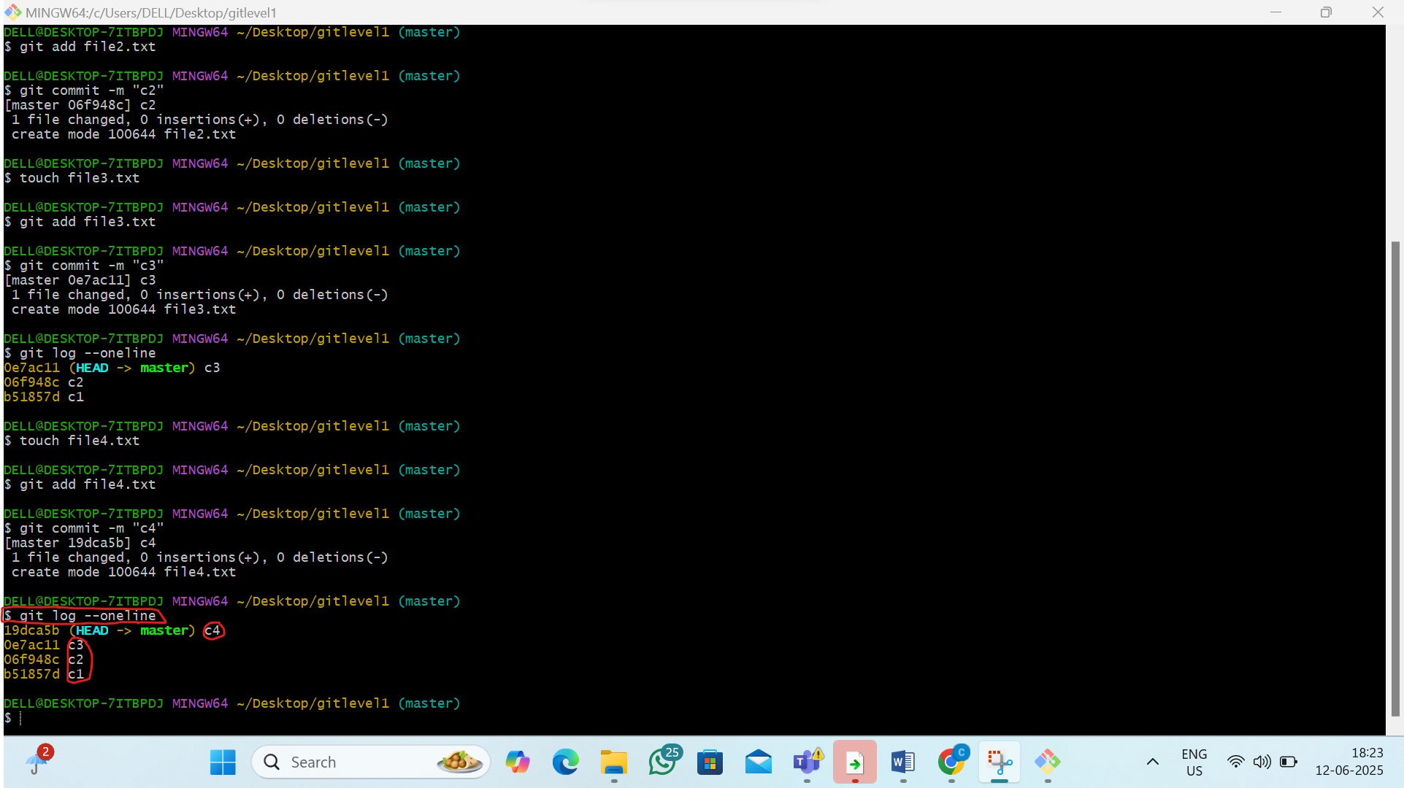

Step 3: Demonstrate git reset Options(if don’t want c4)
1)SOFT Reset :- git reset --soft c3 commit id
2)MIXED Reset:- git reset --mixed c3 commit id
3)HARD Reset:-git reset –hard c3 commit id
1)SOFT :- git reset --soft (c3 commit id)

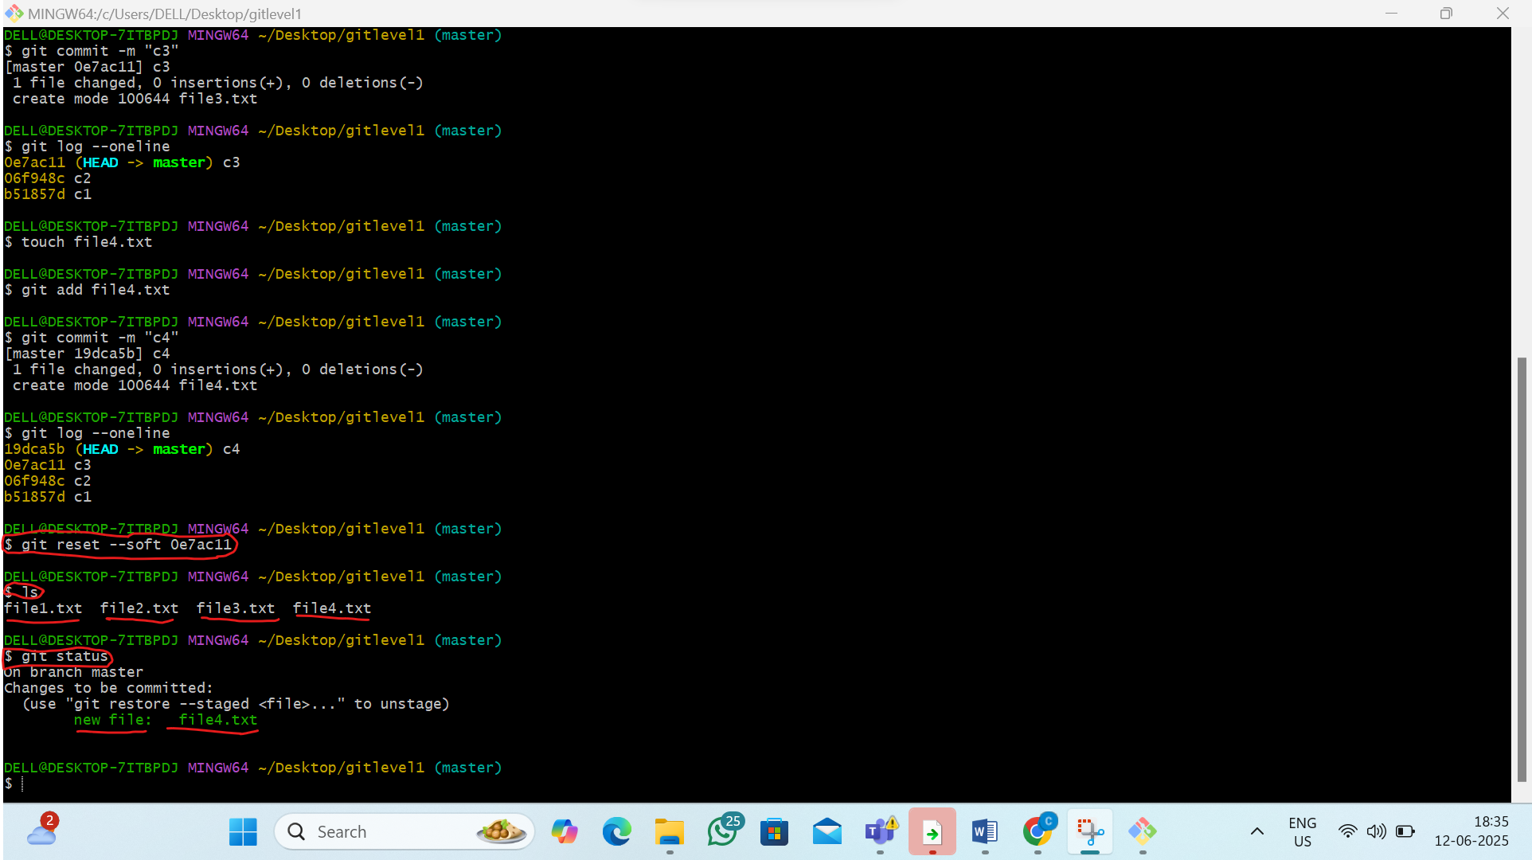
2)MIXED :- git reset --mixed c3 (commit id)

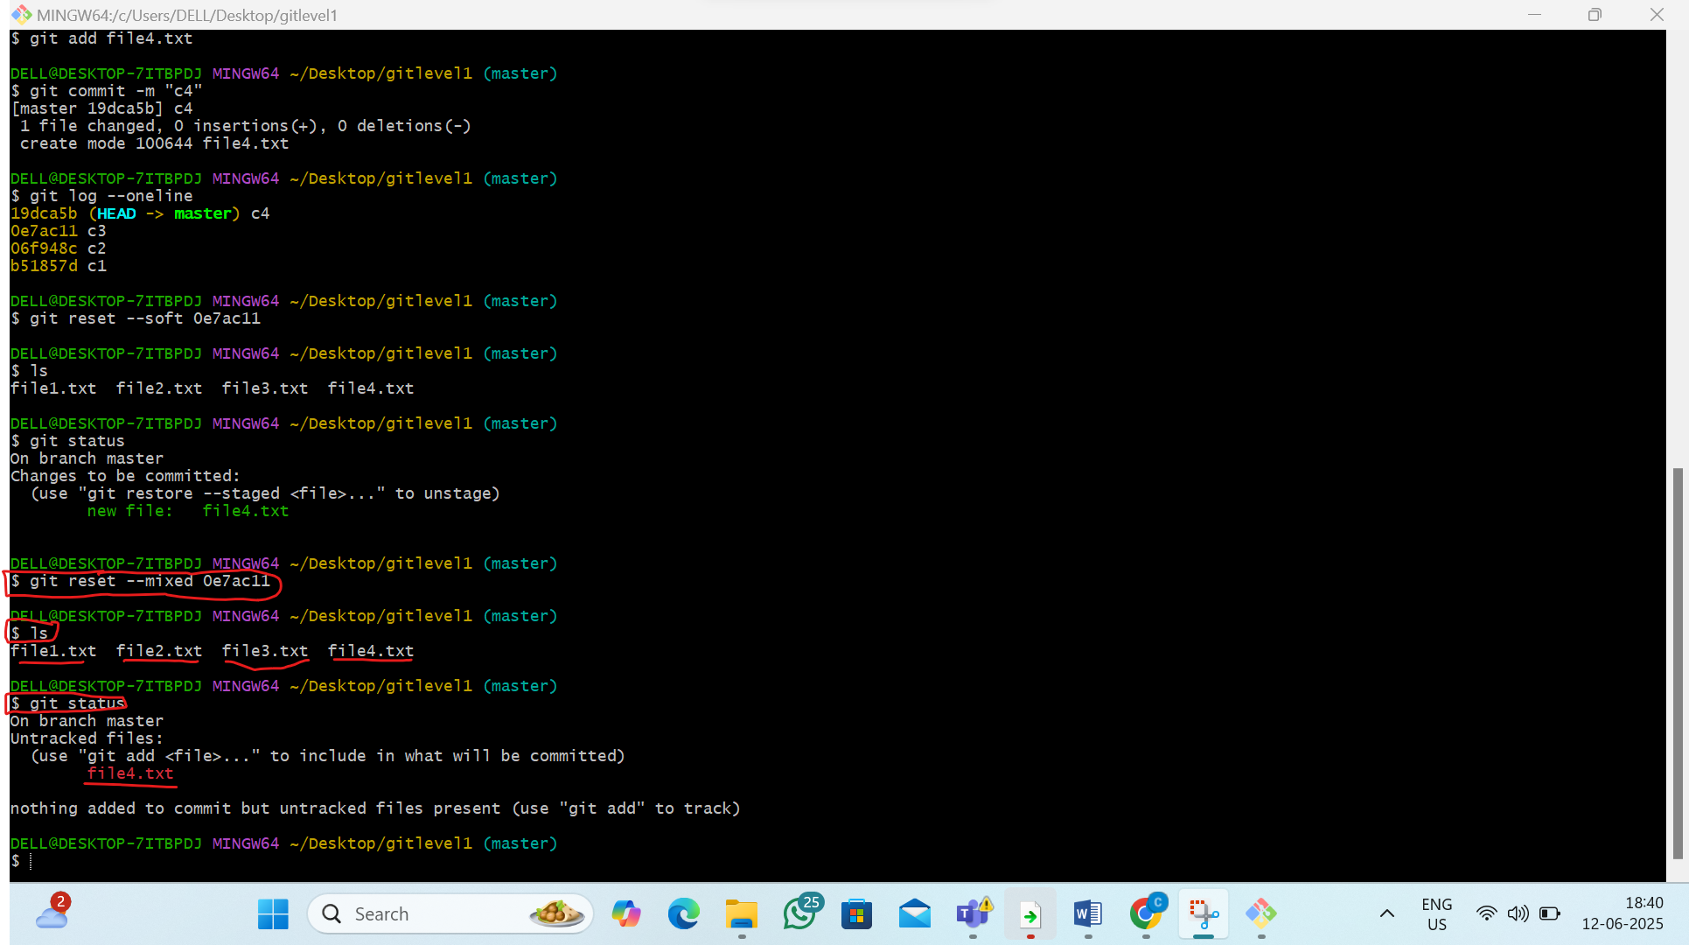

Note :Now iam traking the file 4 by the command git add file4.txt

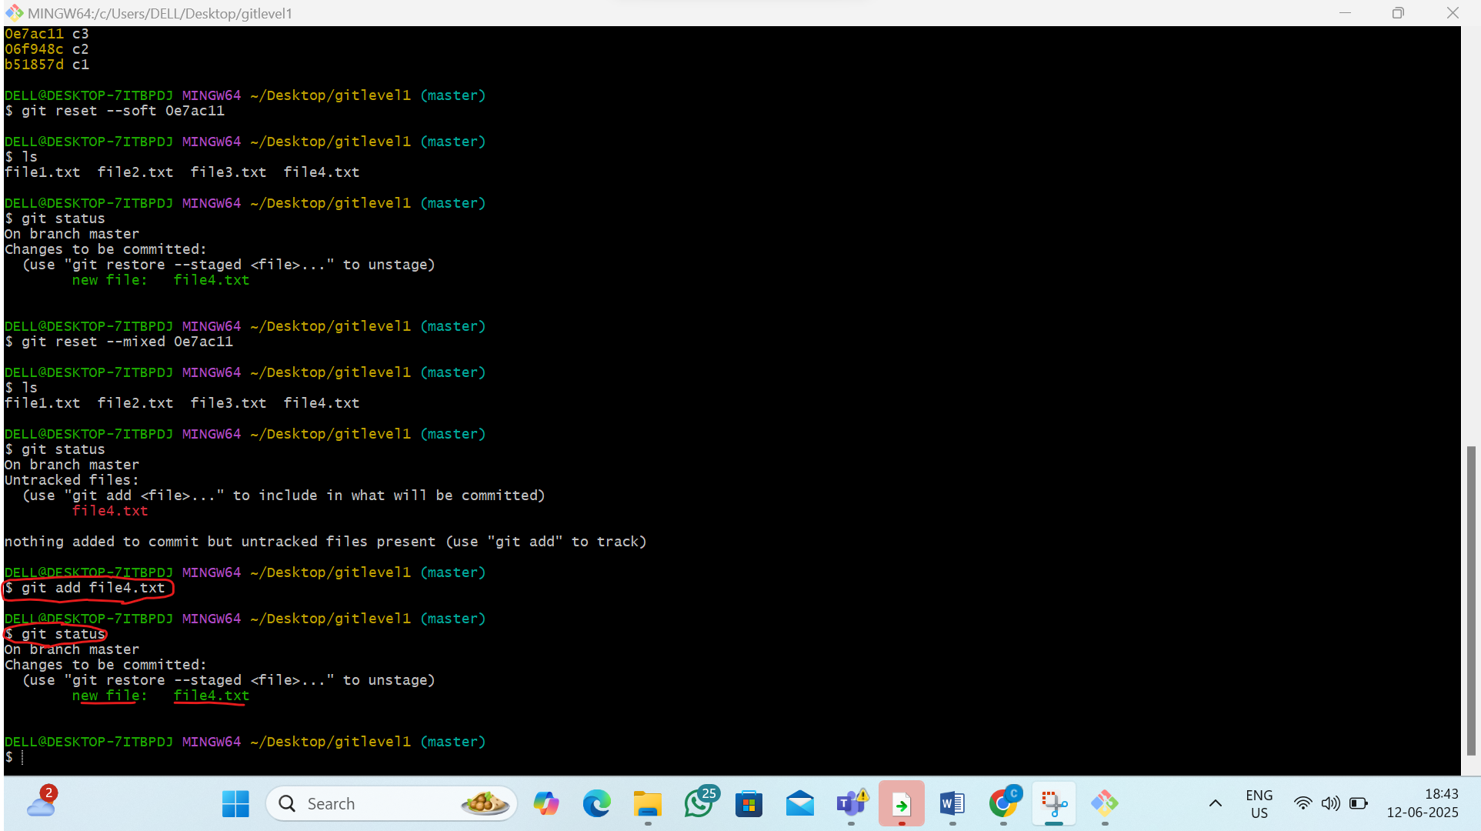

3)HARD RESET :- git reset --hard (c3 commit id)

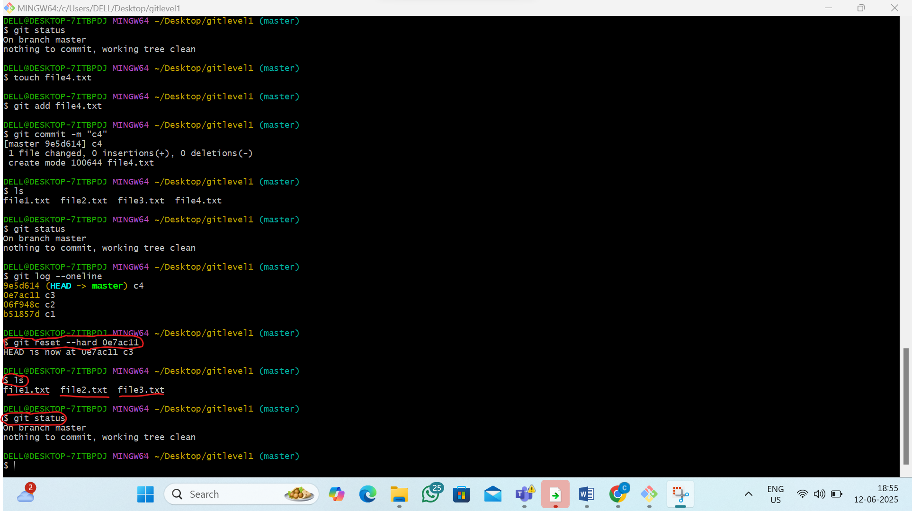

Step 4: Demonstrate git revert
1)Bring back the deleted commit file4
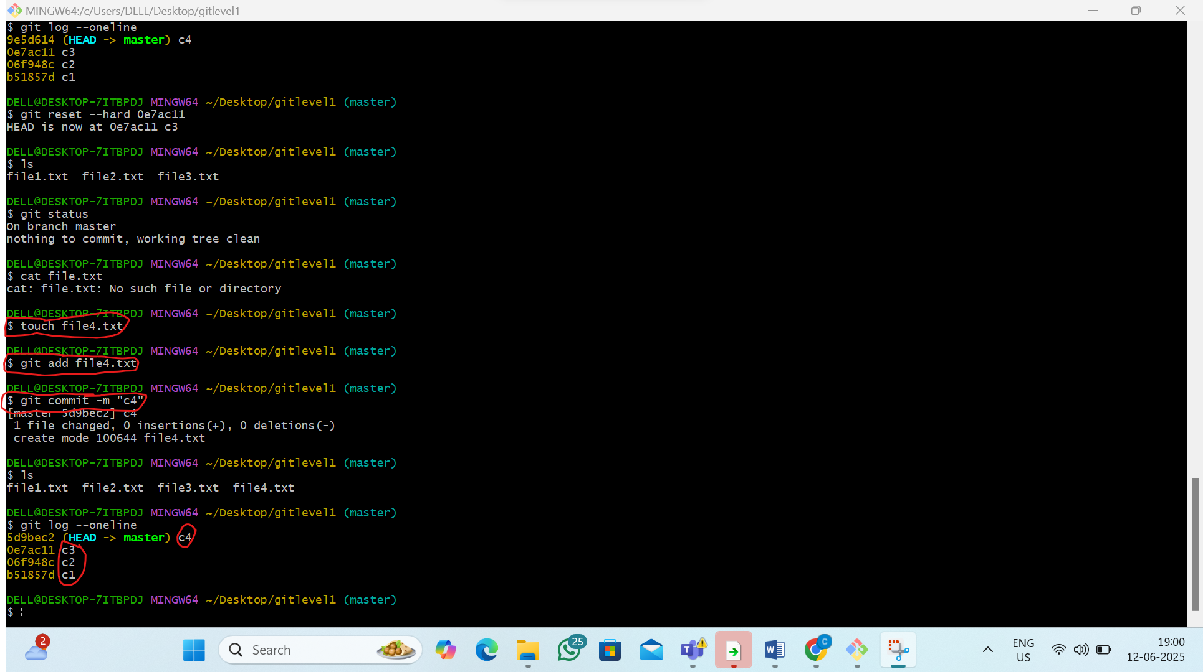

2)now use git revert (iam changing c3 commit to c5 commit)
i)By the command:- git revert (commit id of c3)
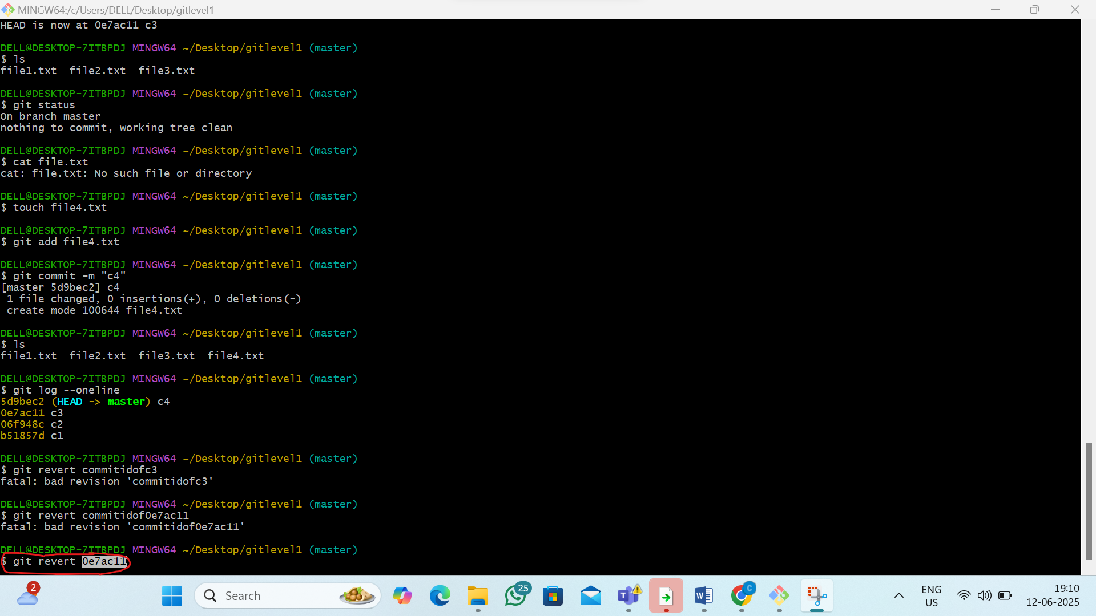

ii)now inside the pop up type c5
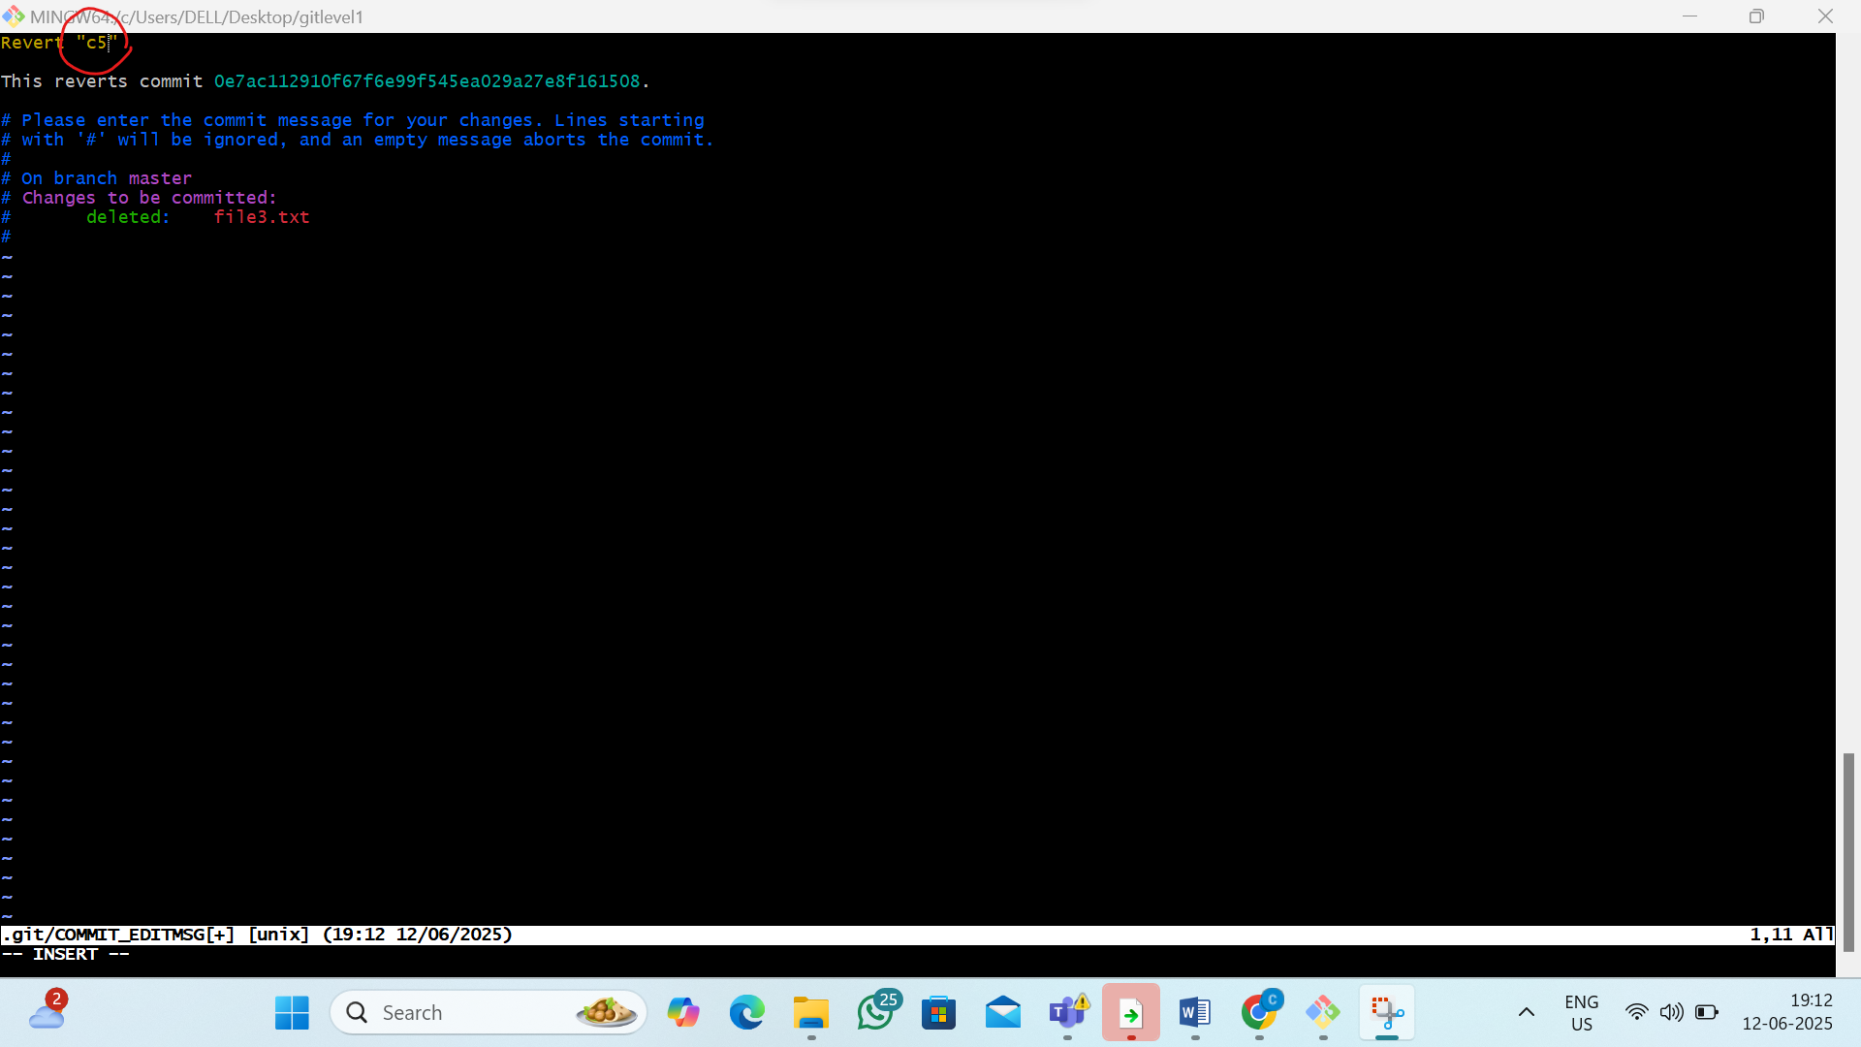
iii)now see the c3 is revert to c5
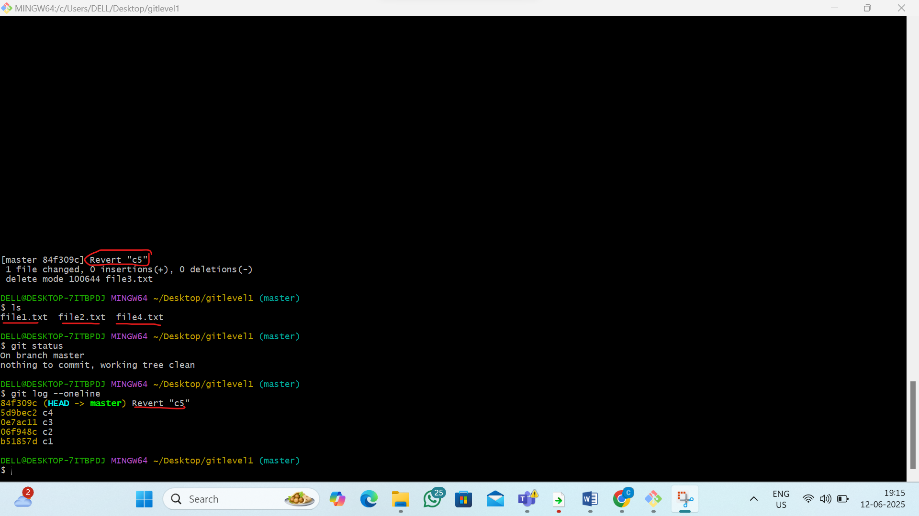
2. L2 - Create Local git repository and demonstrate git merge and Merge Conflicts with the steps to resolve merge conflicts
Step 1: Create a Git Repository
1)Create the file and go inside the file
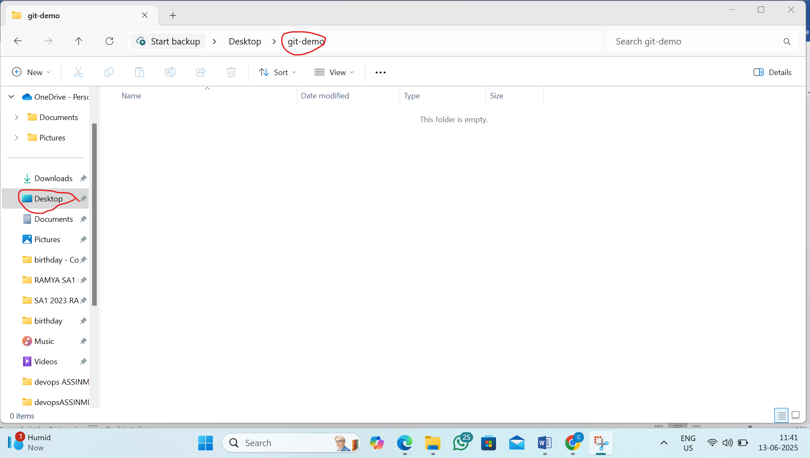
2) STEP2:-from that file open gitbash terminal
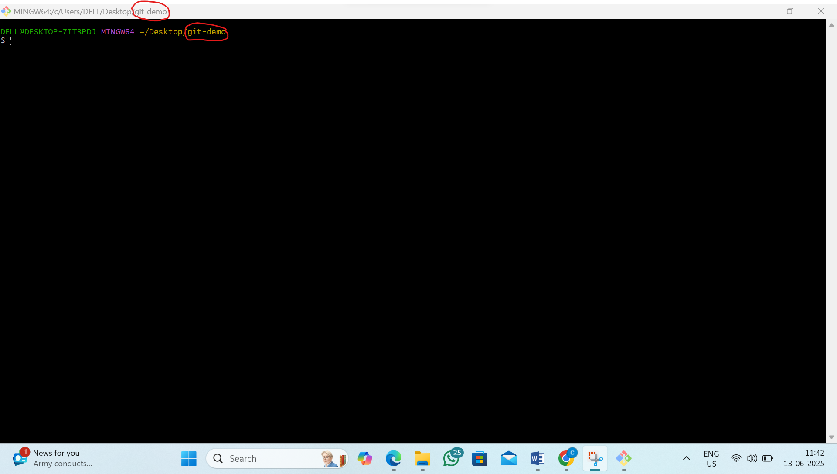
3) Initialize a new Git repository
By the command:- git init
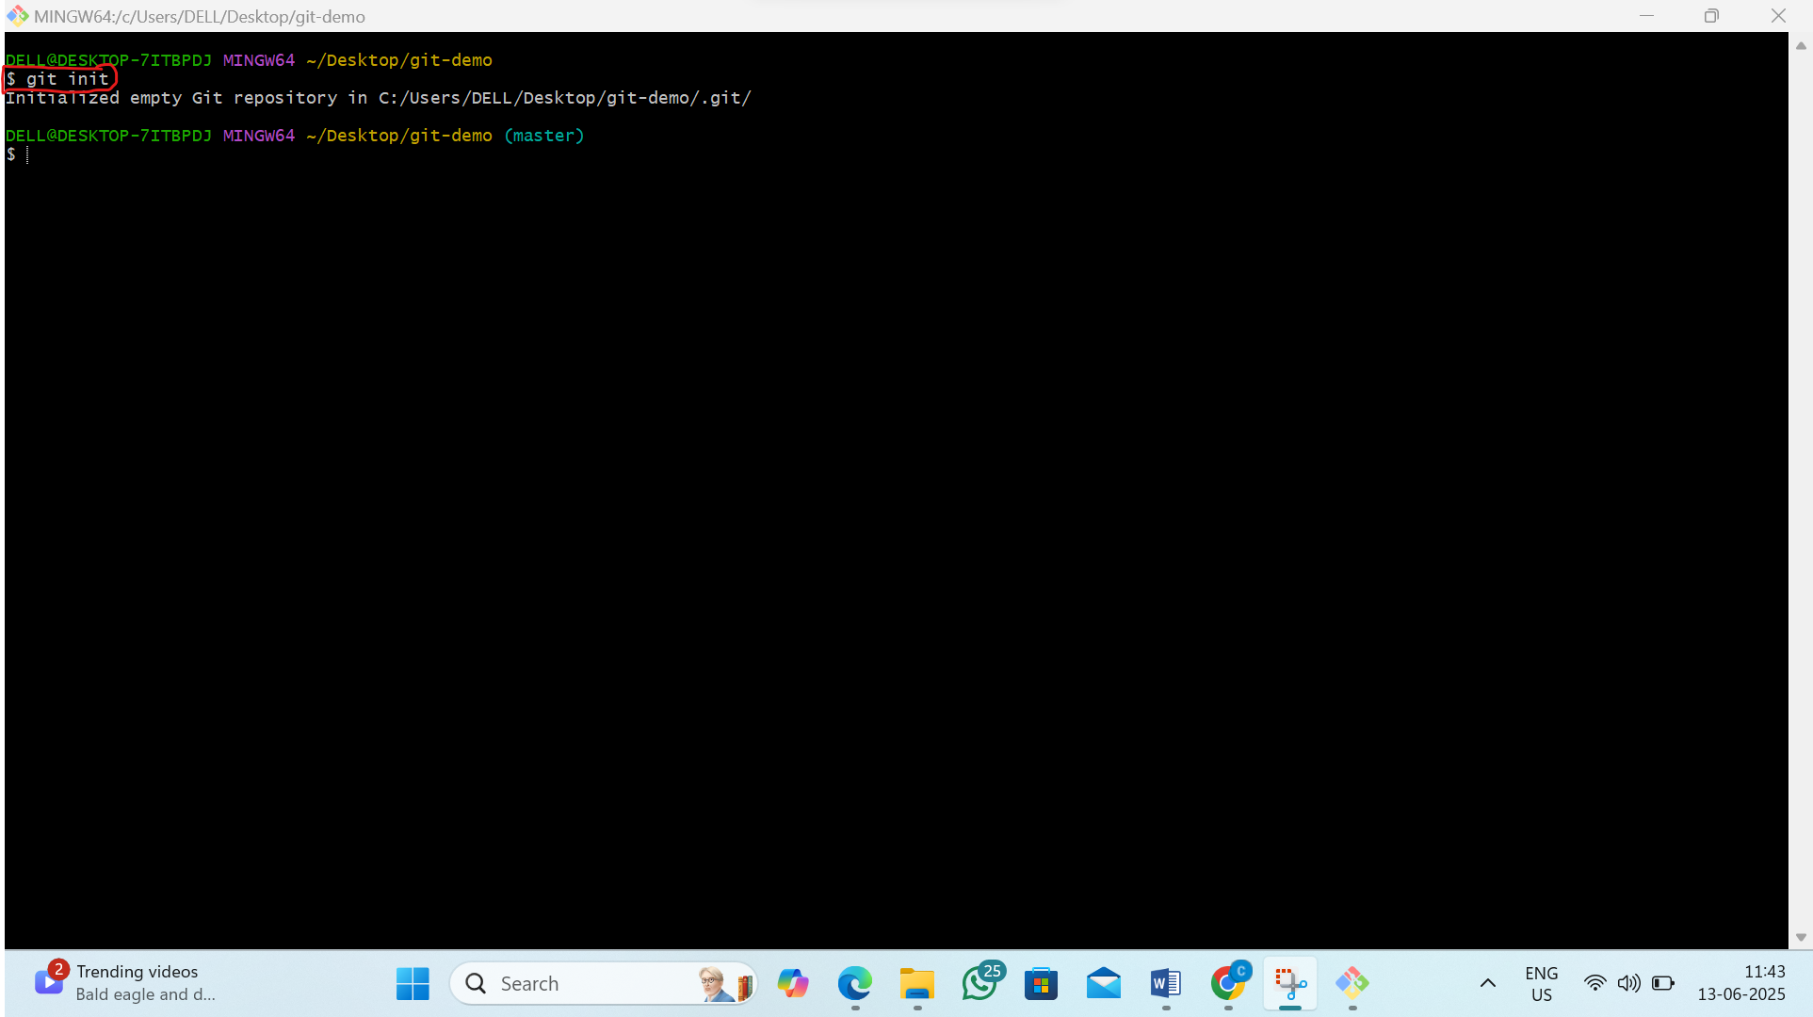
Step2 :- Create a file and commit in master branch
1)by the command :-vi file1.sh
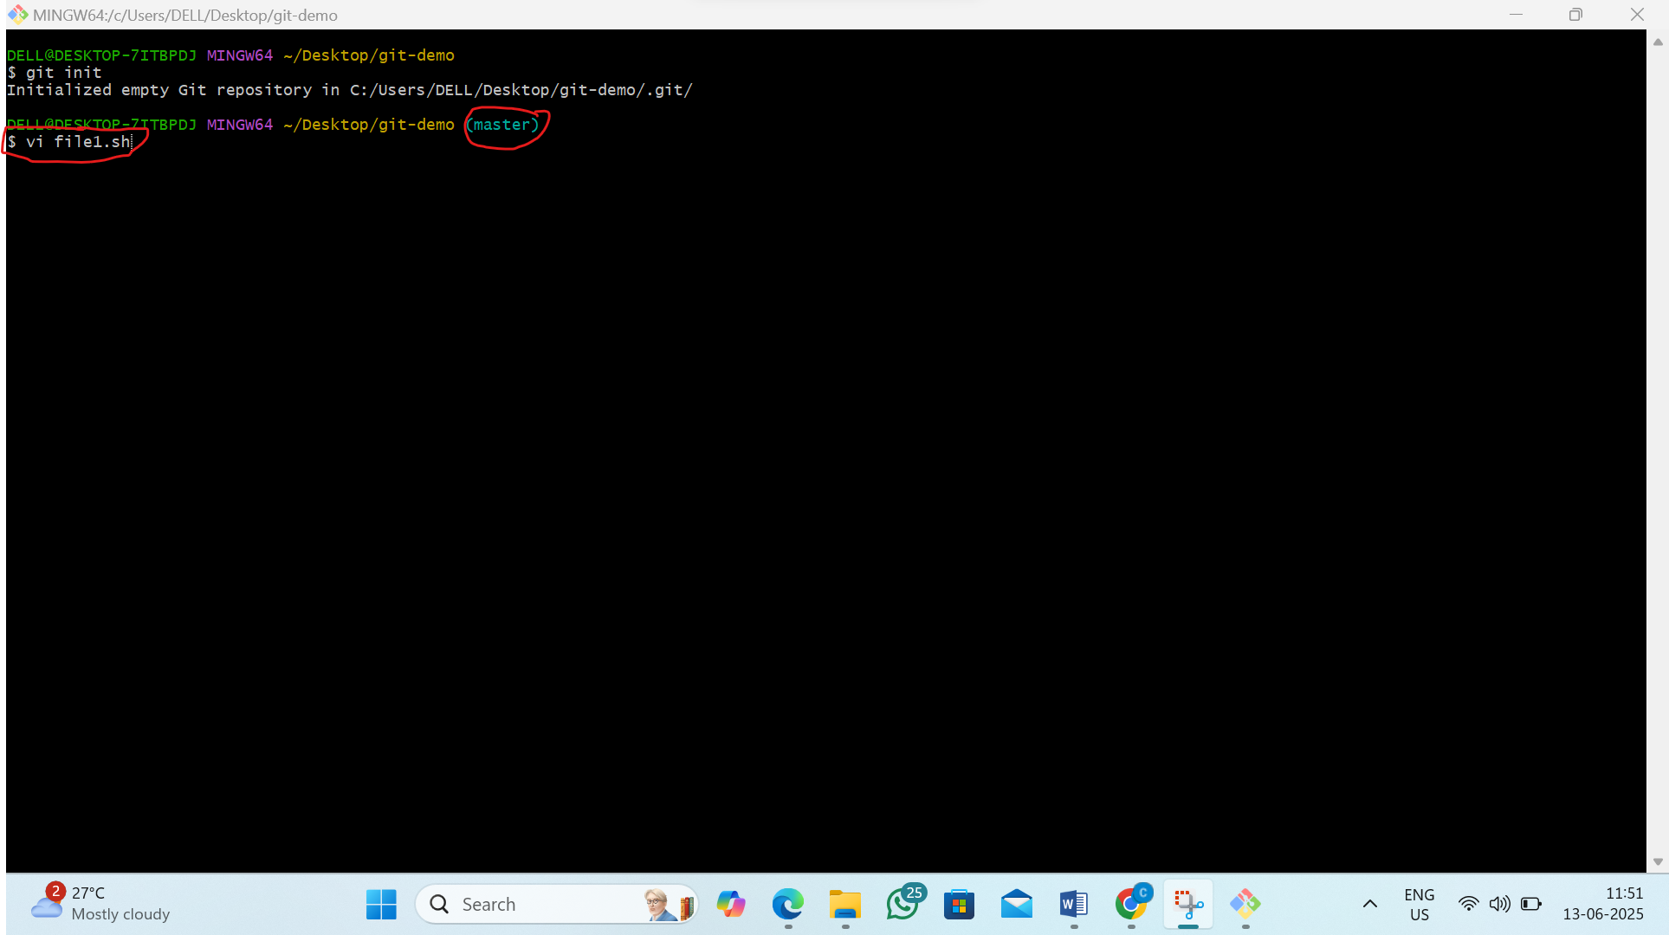

2)Now inside the file type “Hello” ,and press esc :wq
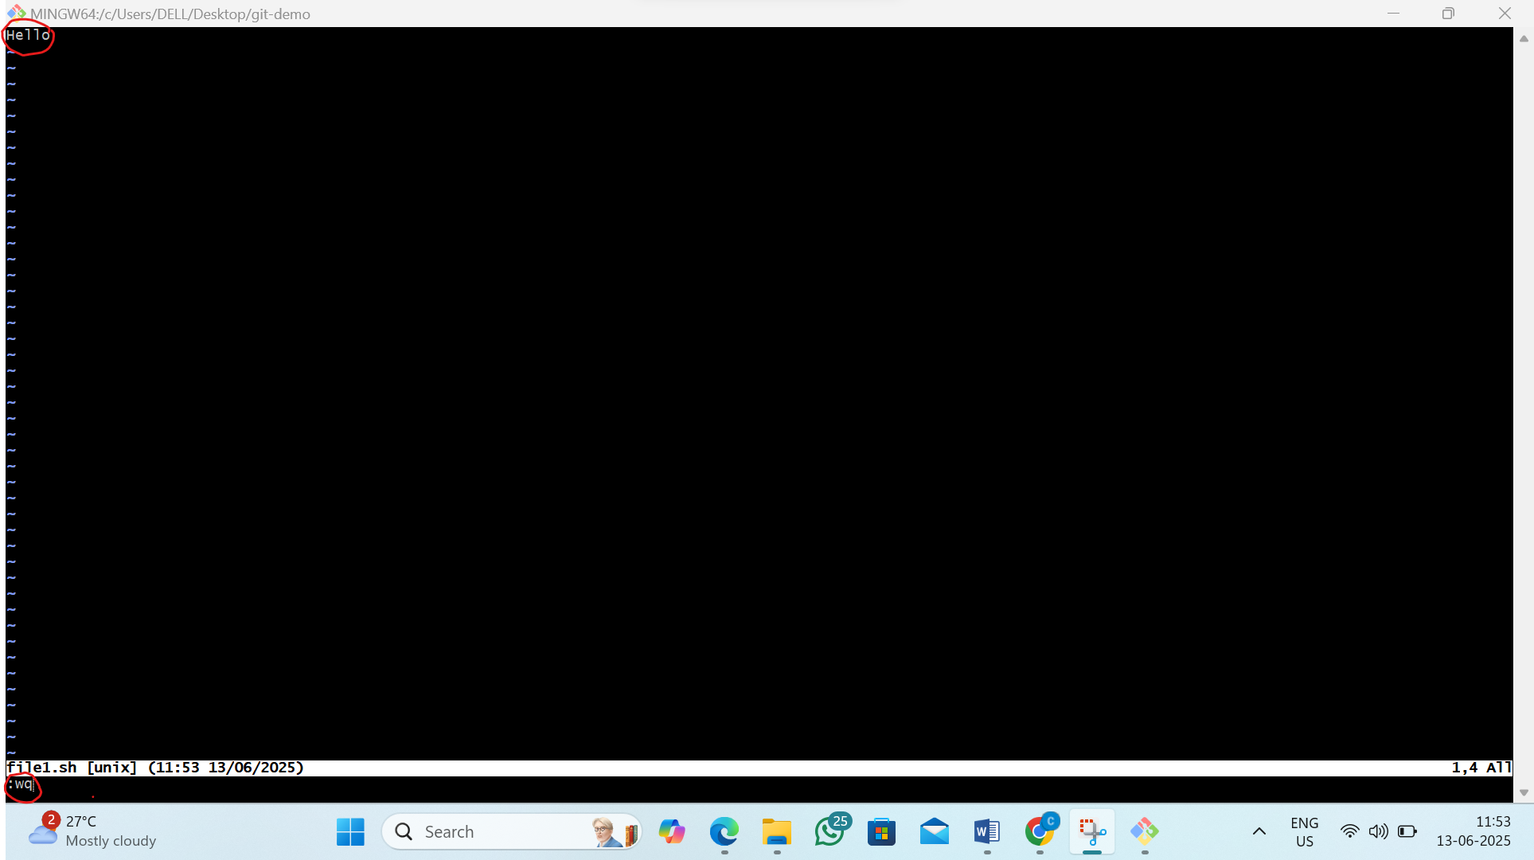
3) See the status and Track the file and commit file as “master”
by the command : 1)git status
2) git add file1.sh
3) git commit -m “master”
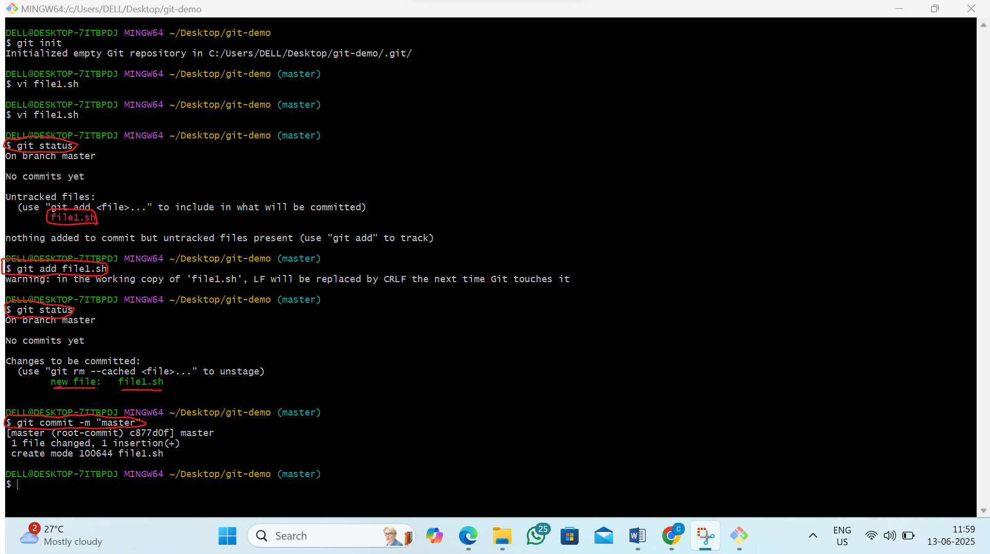

Step3 :Create two new branch’s as local branch and remote branch
by the command:1)git branch local
2)git branch remote
3)git branch
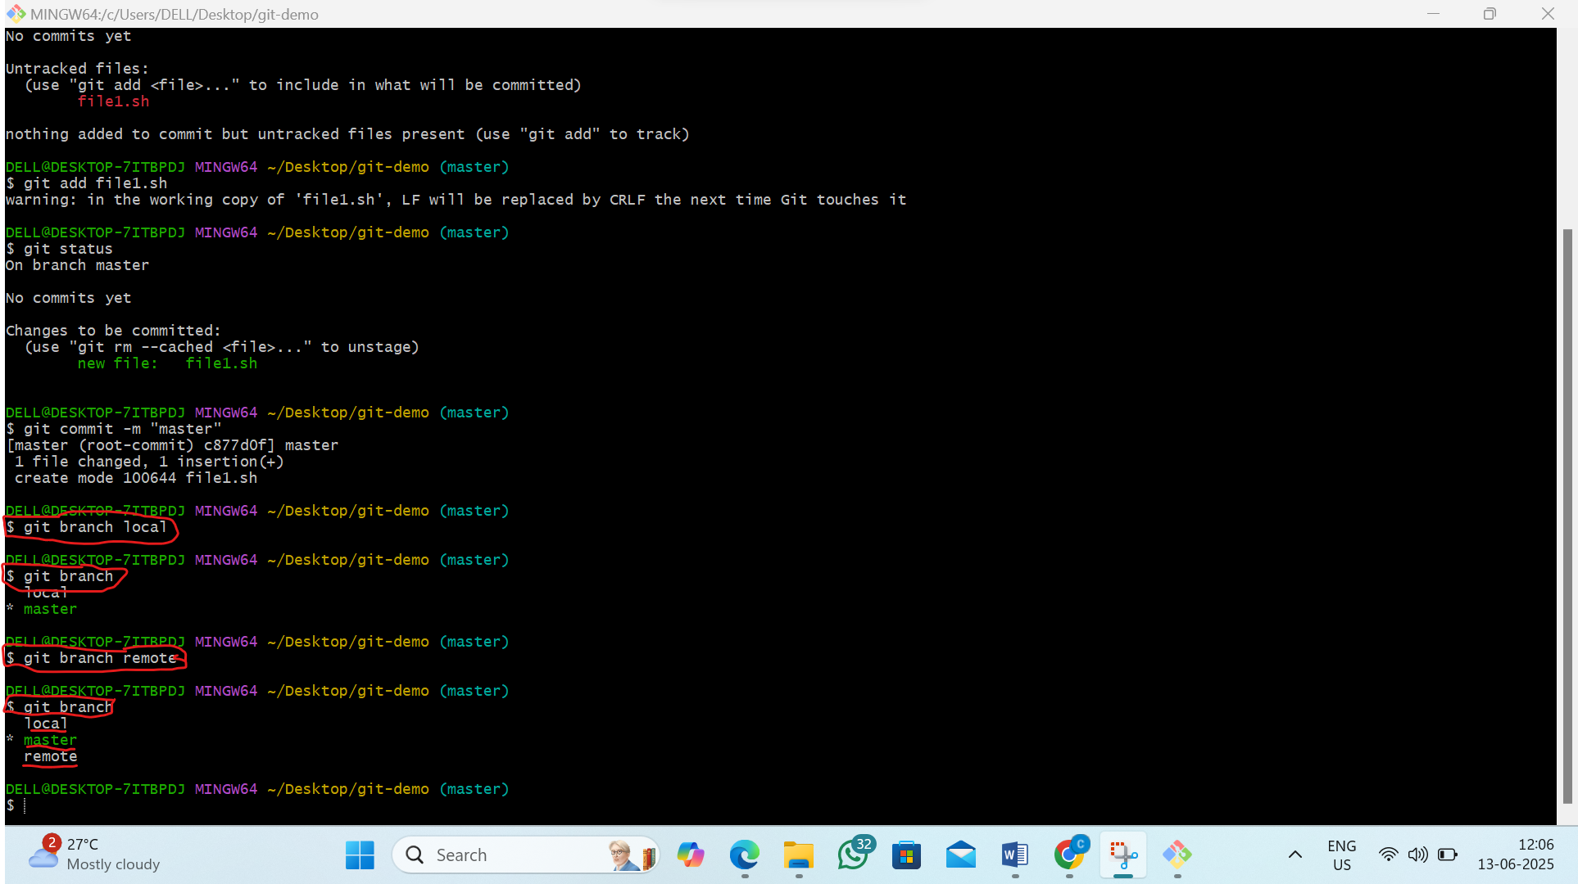Step4:switch to local branch and modify file1.sh and commit as “local”
1)by the command:1)git checkout local
2)ls
3)vi file1.sh
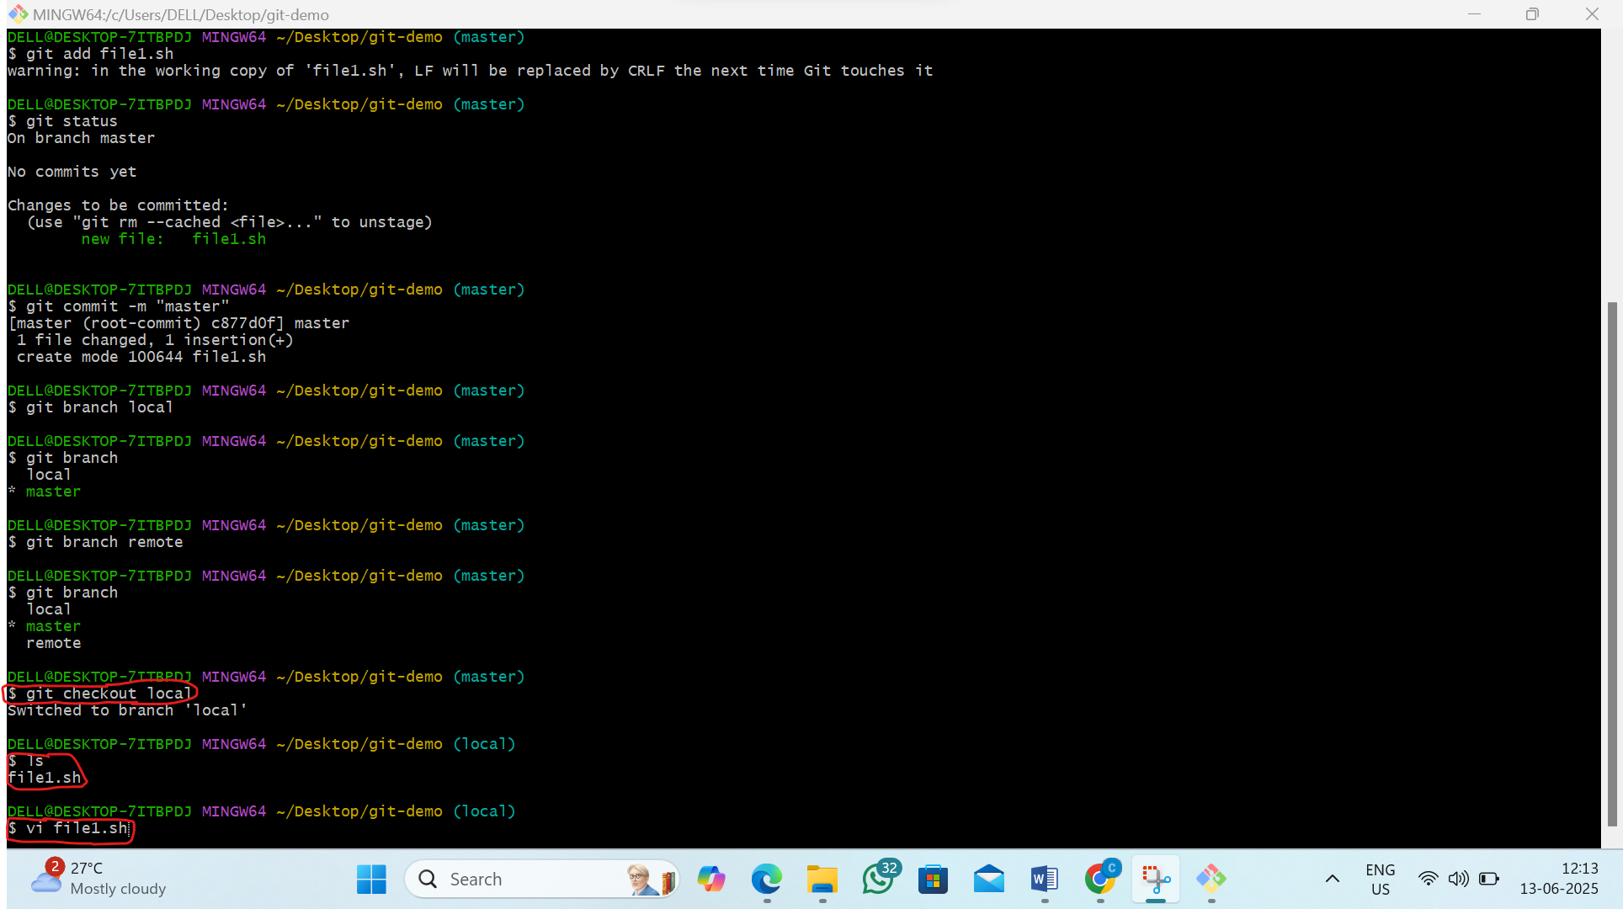
2)now inside type “ file” and press esc :wq
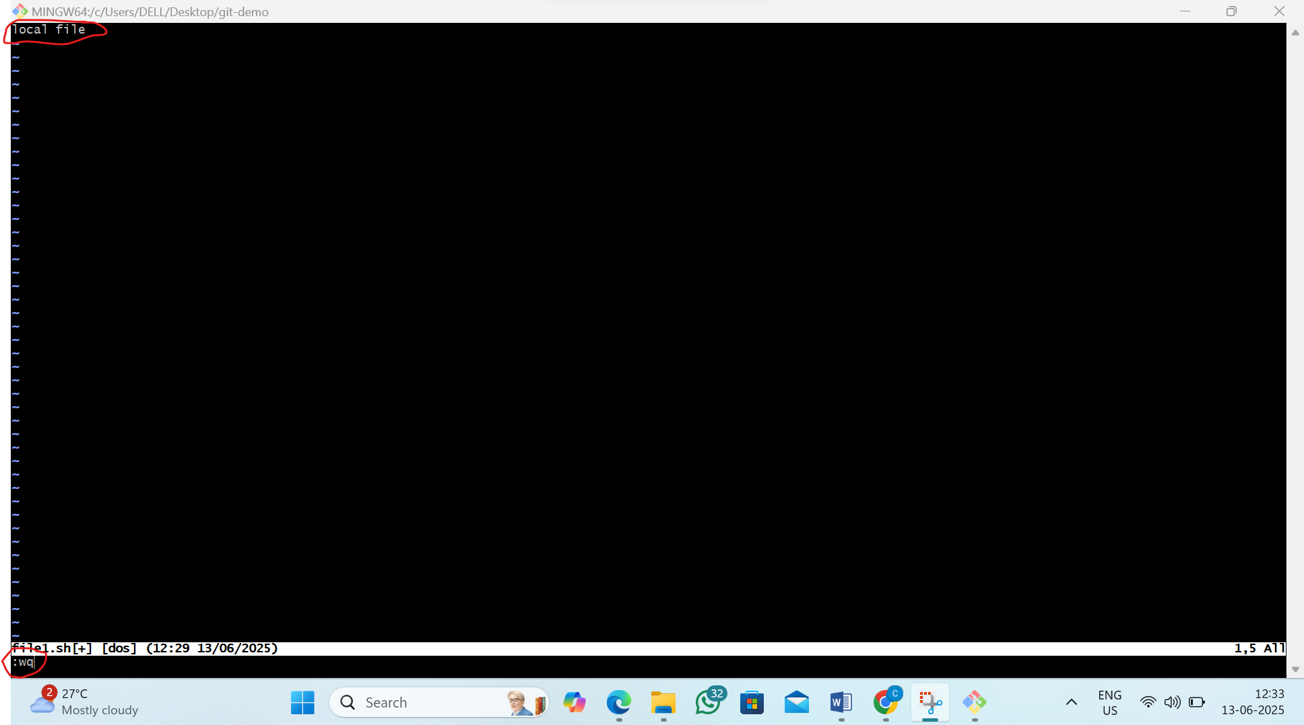
3)now track the file and commit as local file
by the command:1)git add file1.sh
2)git commit -m “local”
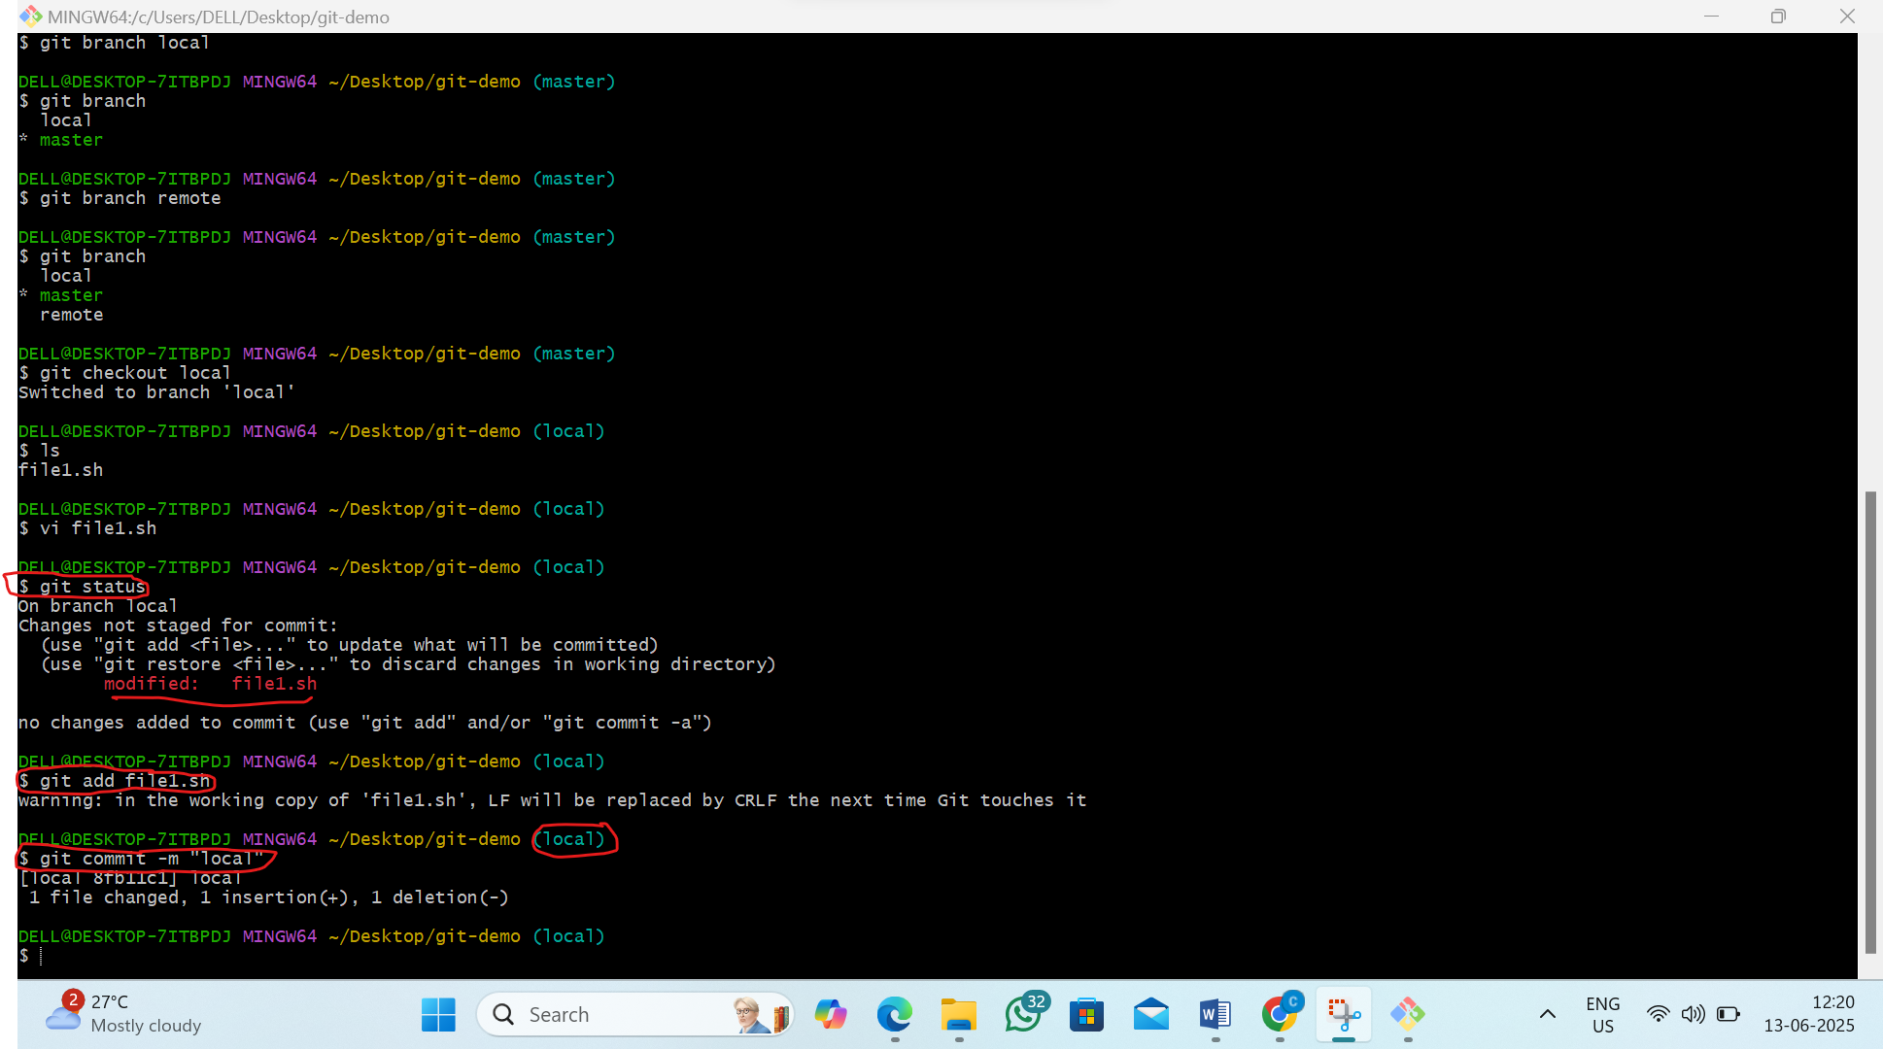

Step5:Now switch to remote branch and modify file1.sh and commit as “remote”
1)by the command:1)git checkout remote
2)ls
3)vi file1.sh
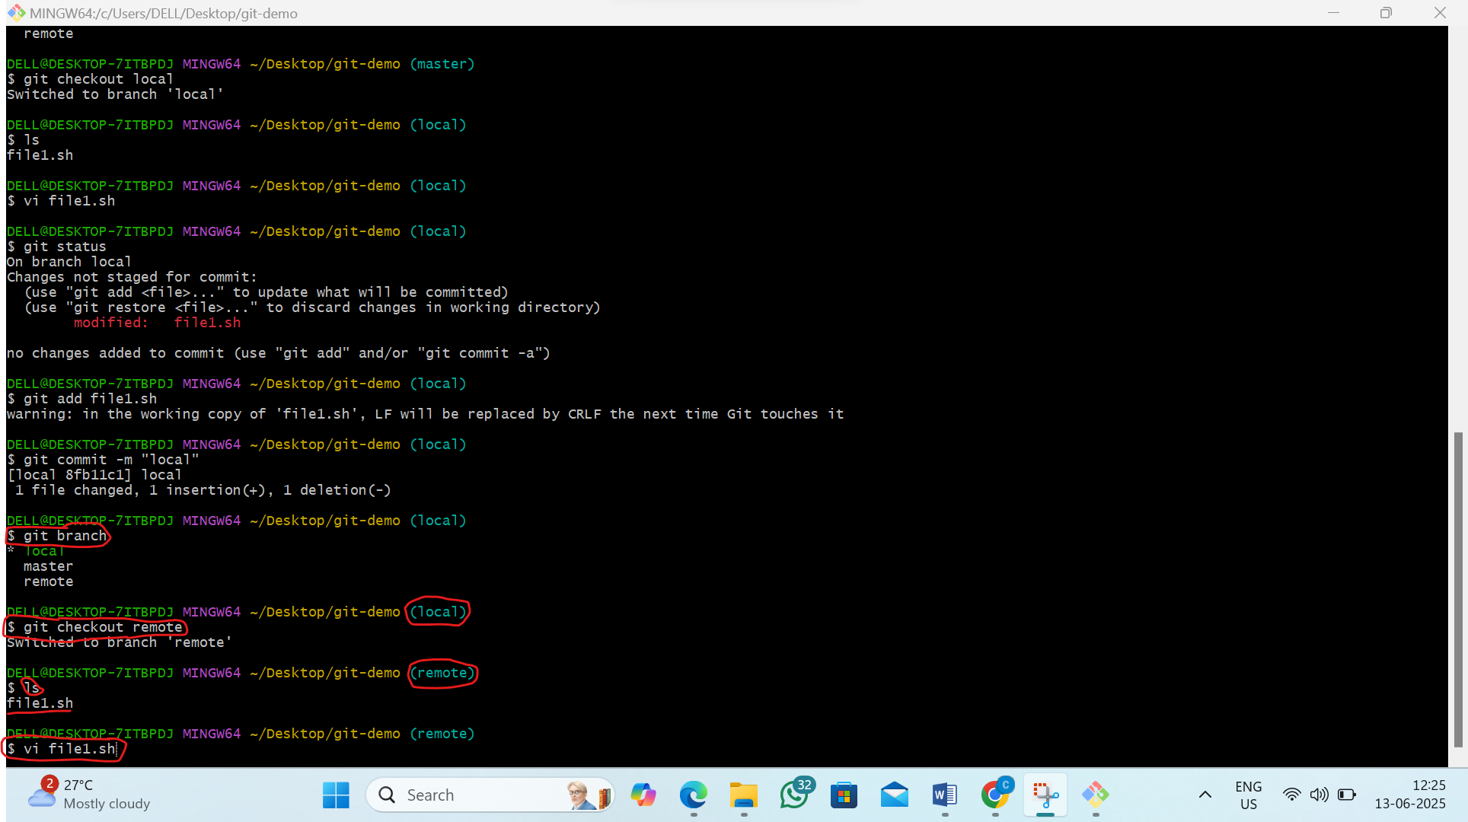
2)now inside type “remote file” and press esc :wq
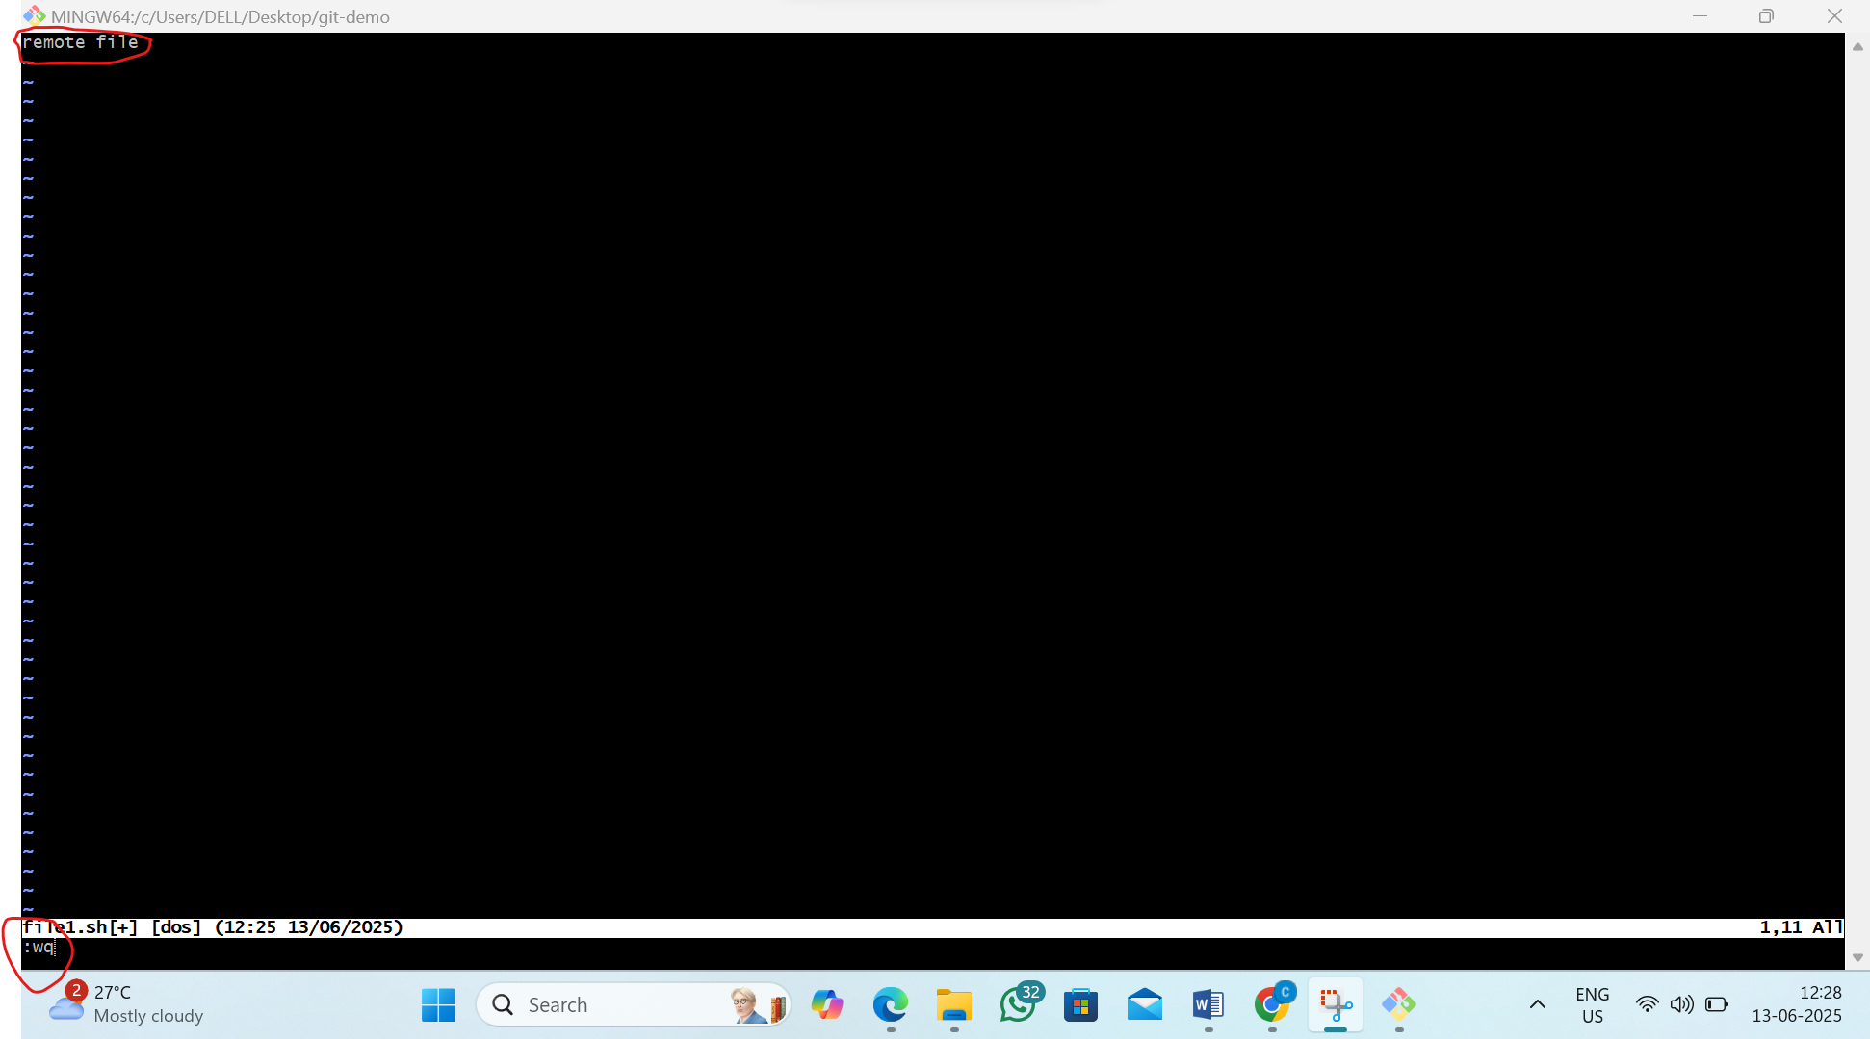
3)now track the file and commit as remote file
by the command:1)git add file1.sh
2)git commit -m “remote”
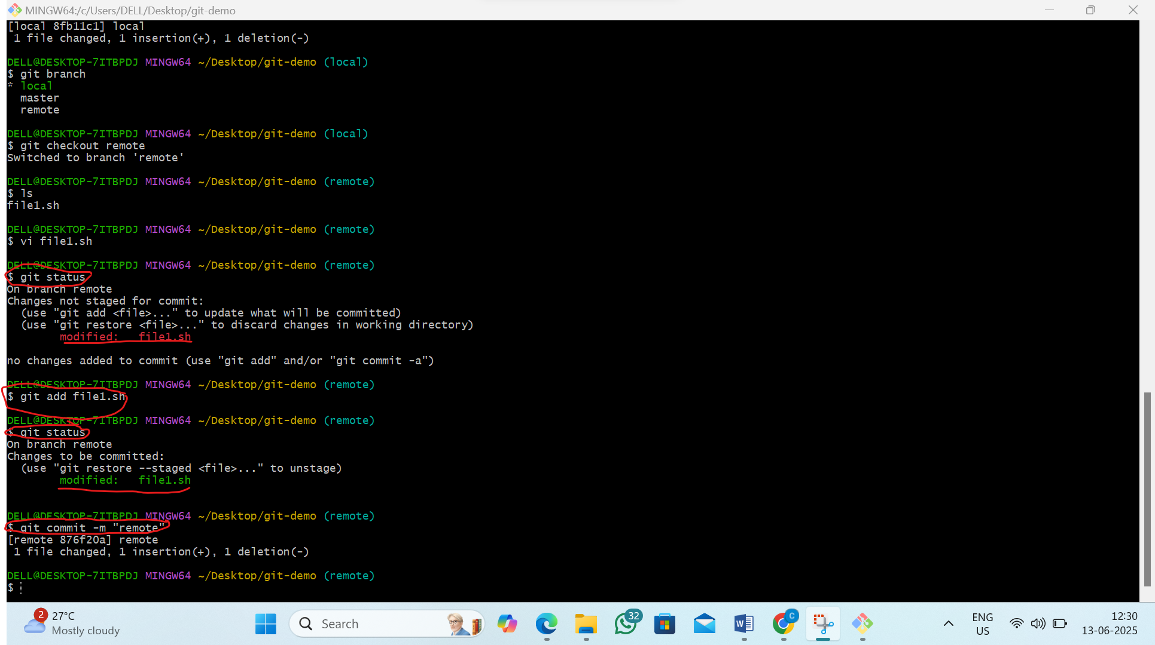
Step6:Now see the git status and see the history of the commit
by the command:1)git status
2)git log
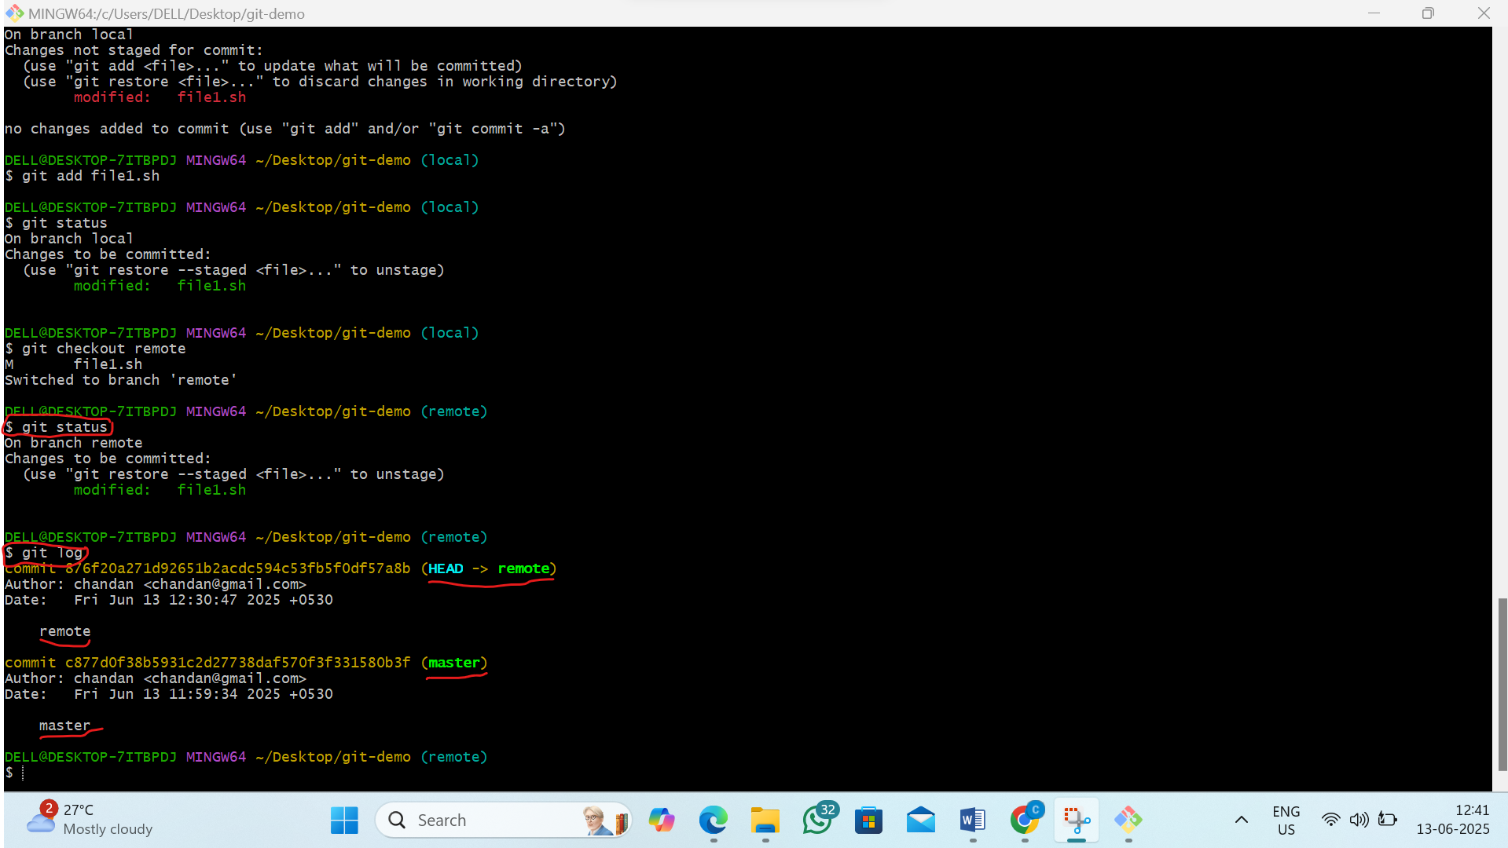

Step7:first commit as modified file and when we go to merge remote and local branch it Conflicts to merge
By the command:1)git commit -m “modified file”
2)git merge local
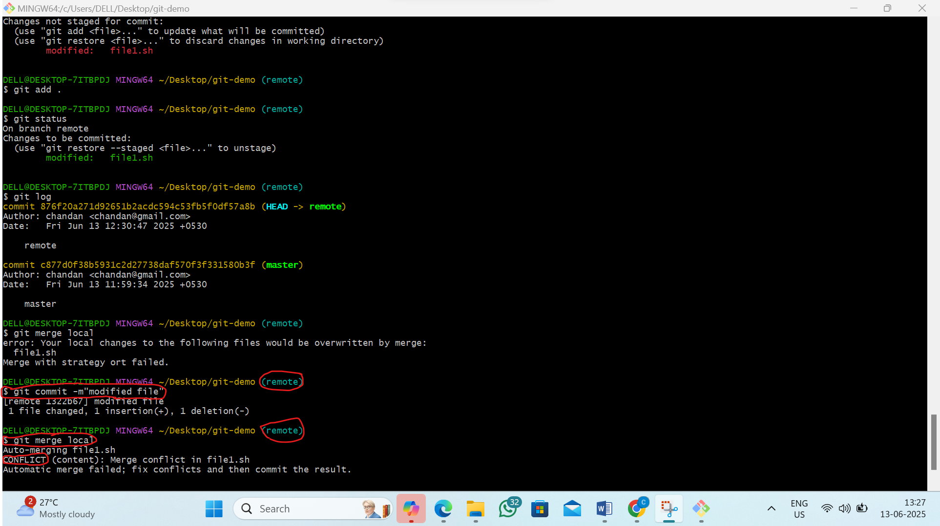
Step8 :to resolve the Conflicts follow the steps below
1) Open file1.sh by pass the command :-vi file1.sh
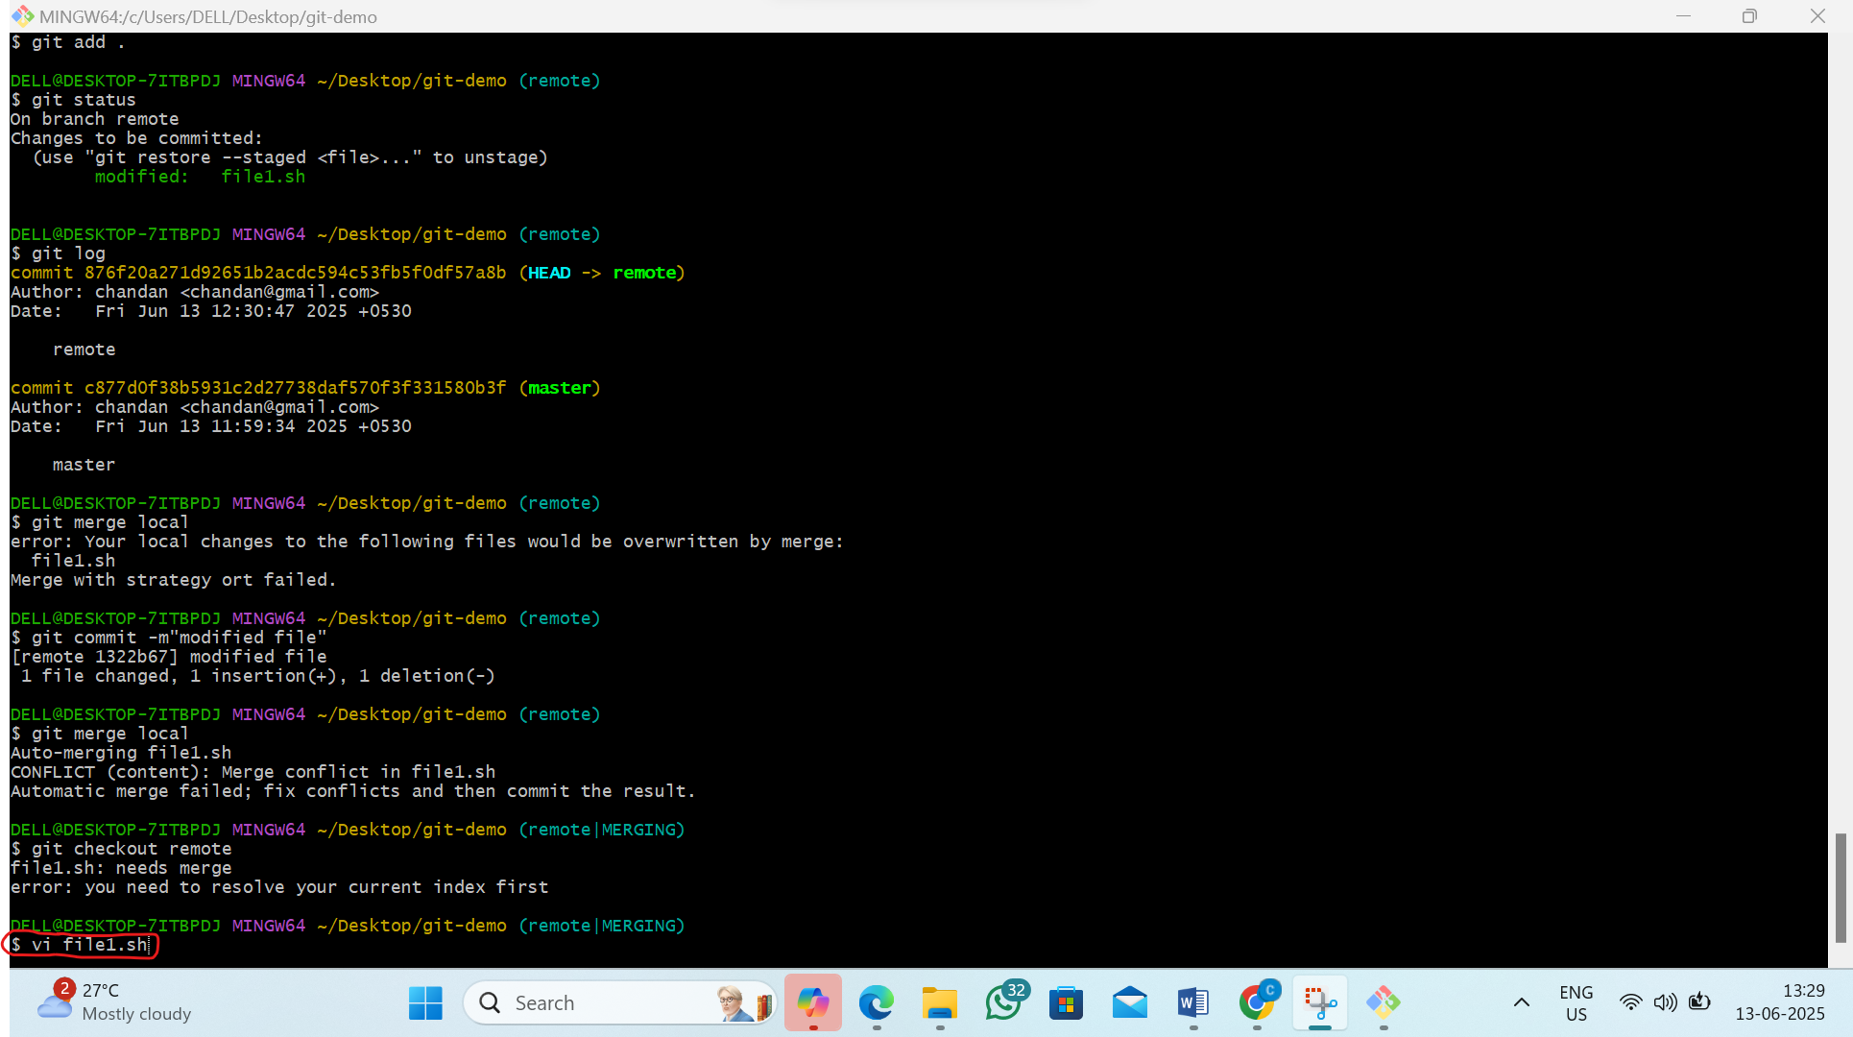

2)it will pop up
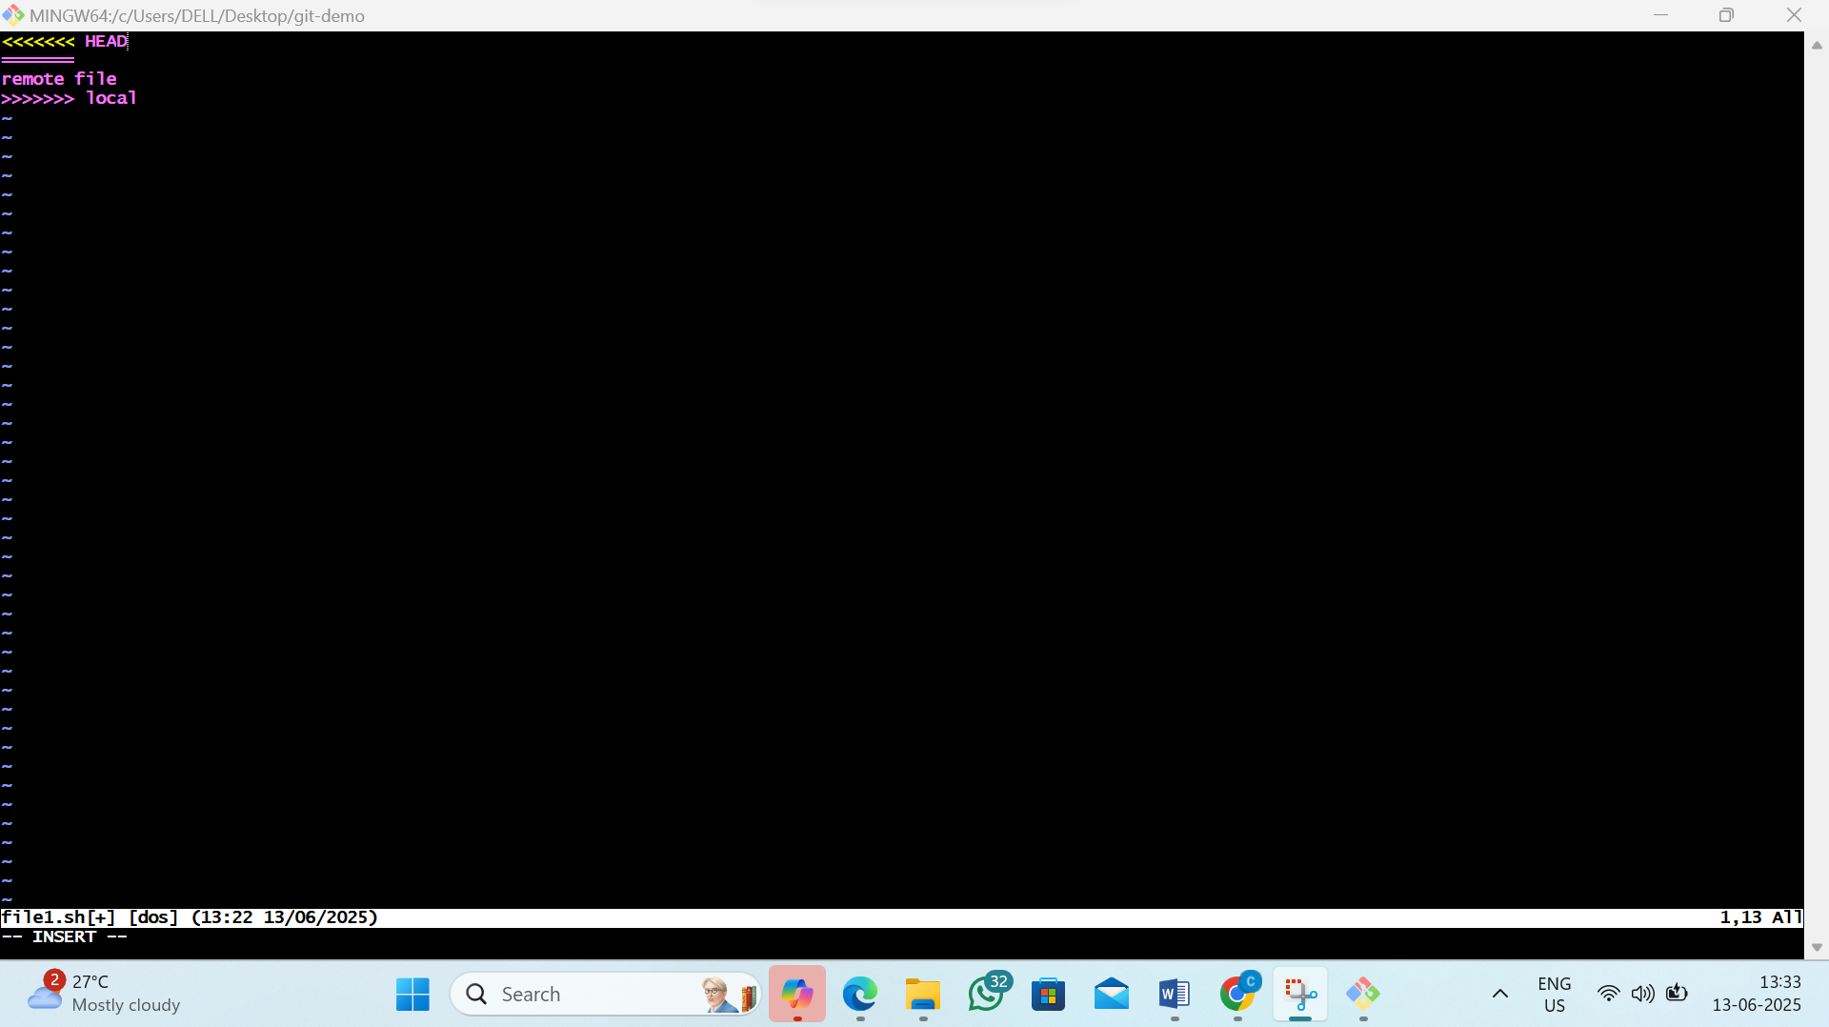

3)remove all the code inside and type “this is from remote and local”
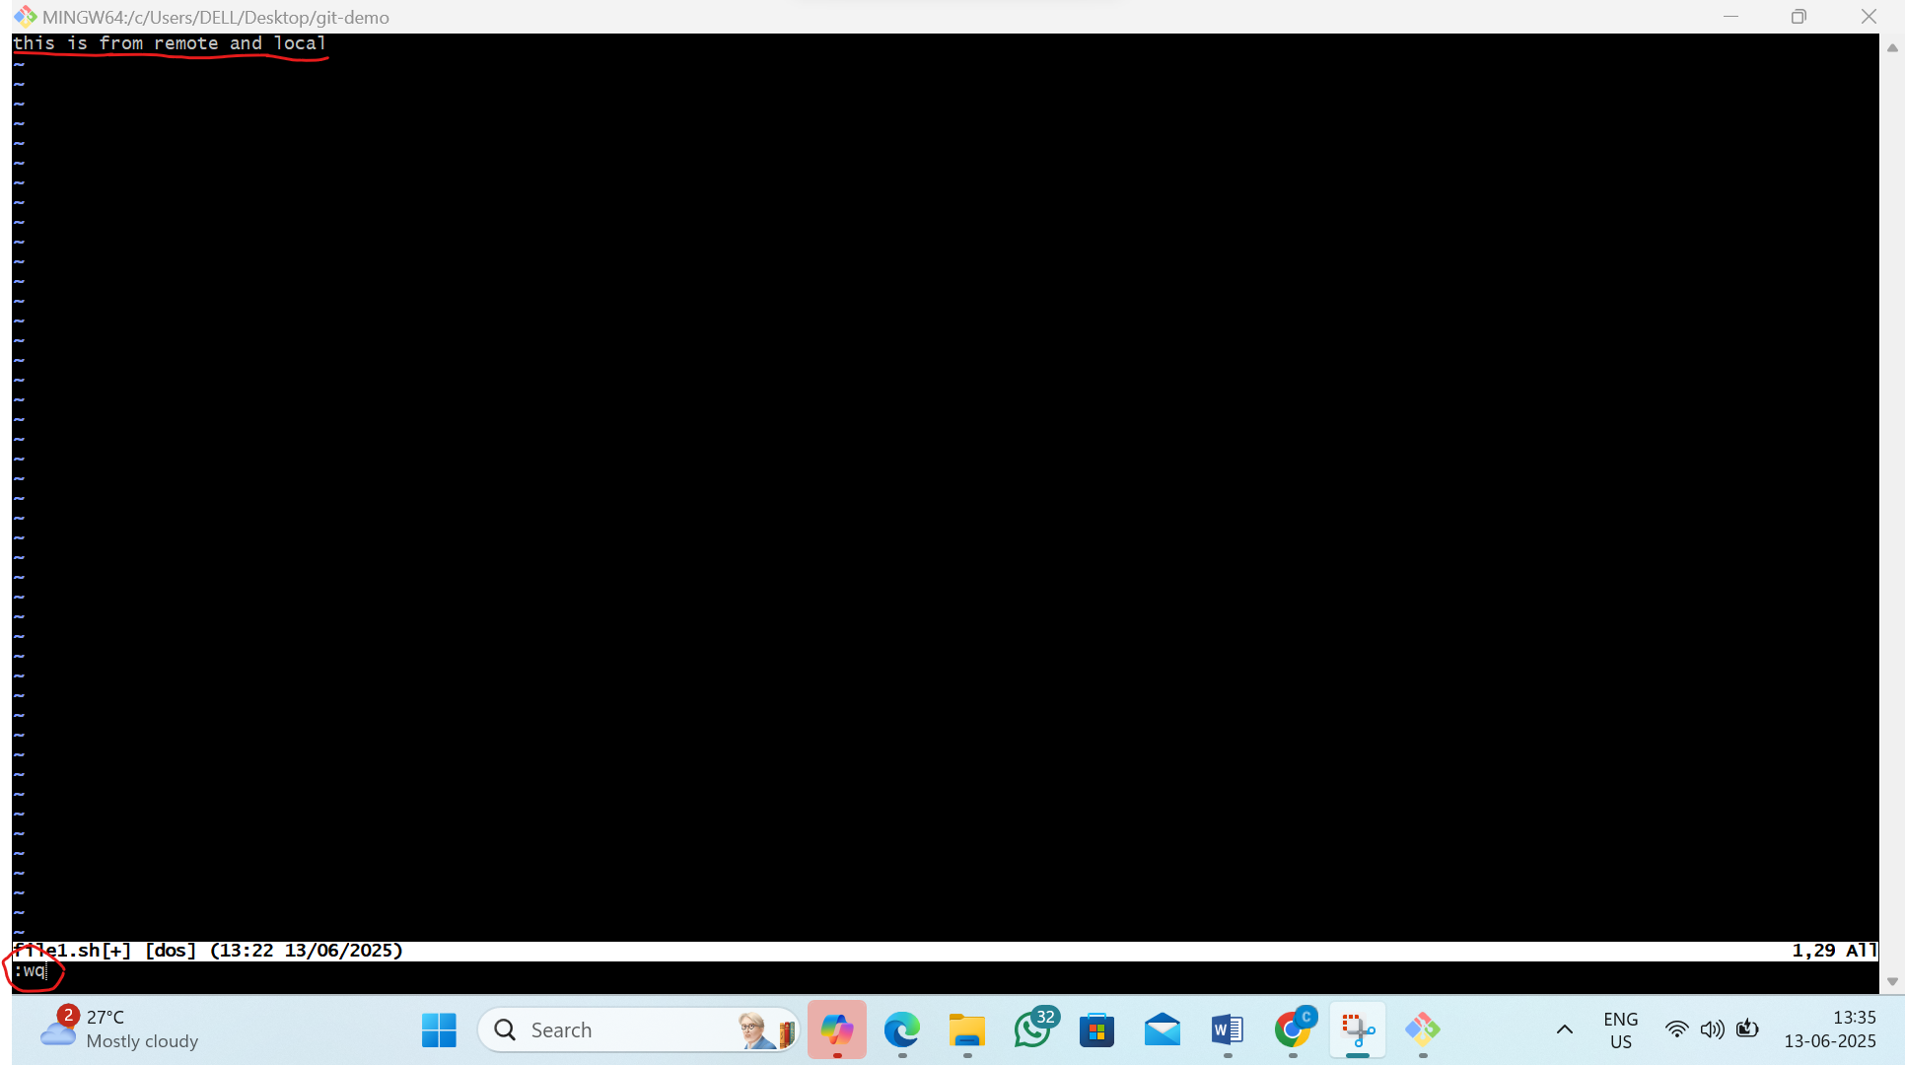

4)now solve the Conflicts
by the command :-1)git status
2)git add.
3)git commit -m”last commit”
4)git merge local
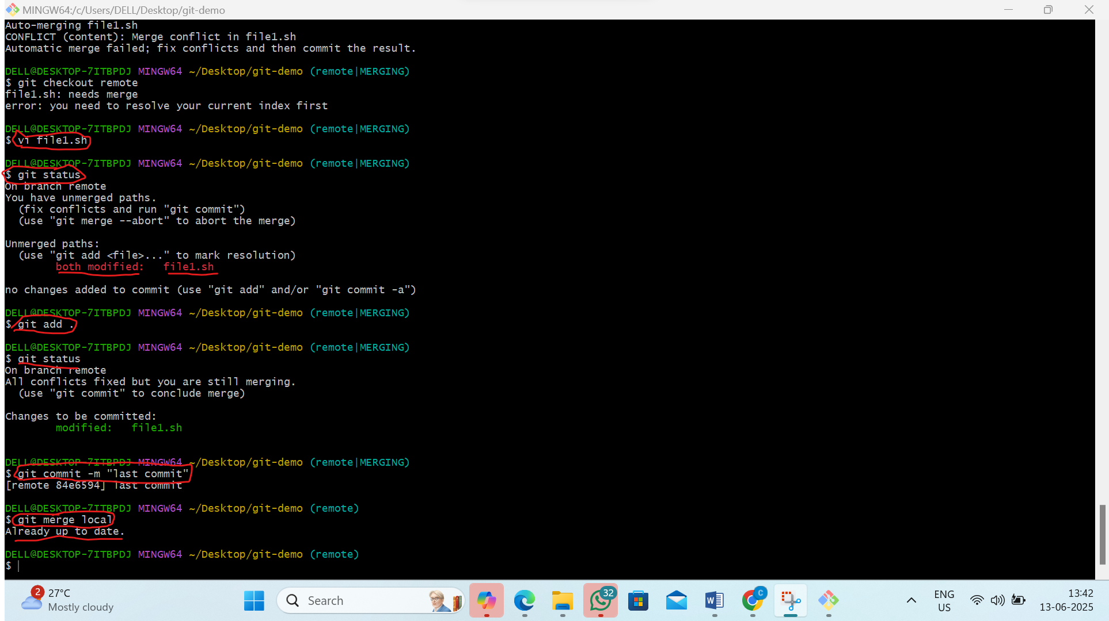

3. L3 - Using Local and Remote git repositories demonstrate git pull and git fetch. Compare the differences
Step 1: Create a Remote Repository on GitHub
1)Go to github and click on new to create new repository
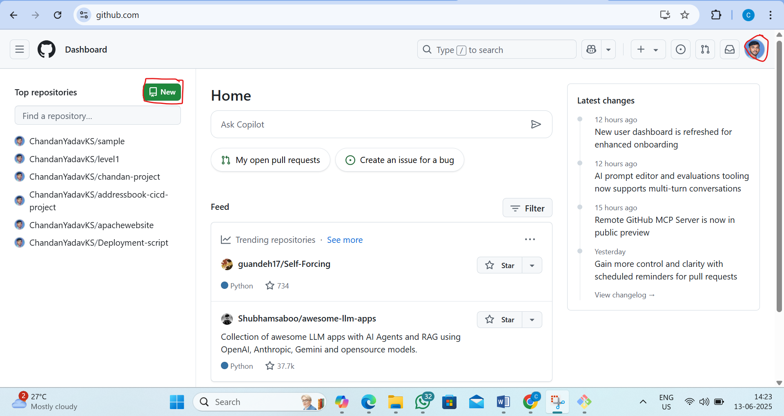
2)create repository as name level3
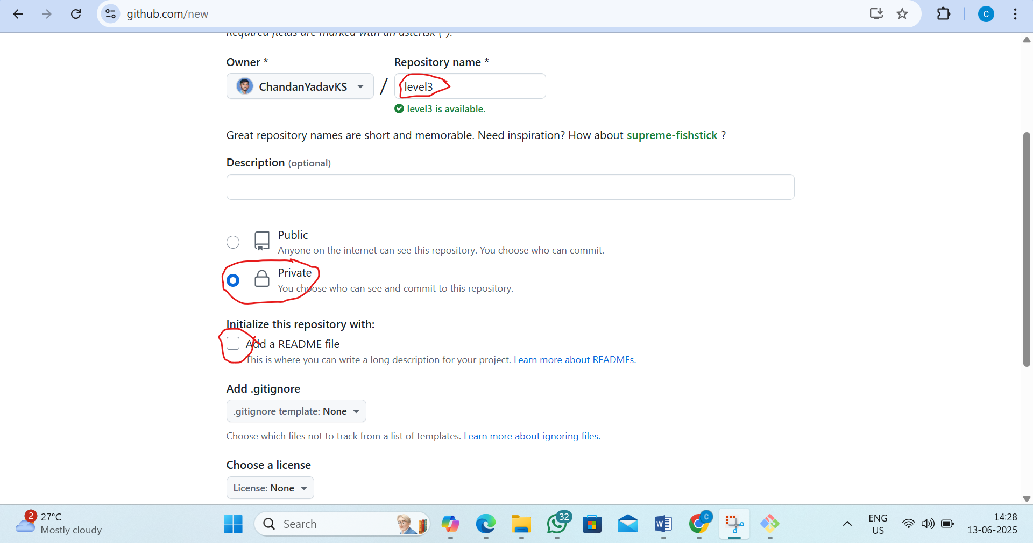3)copy the link of repository
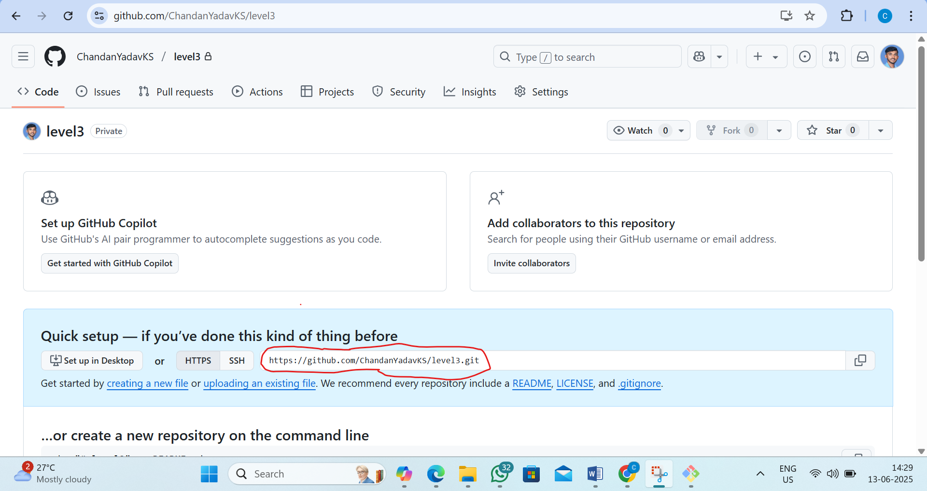

Step2:create the floder in locally
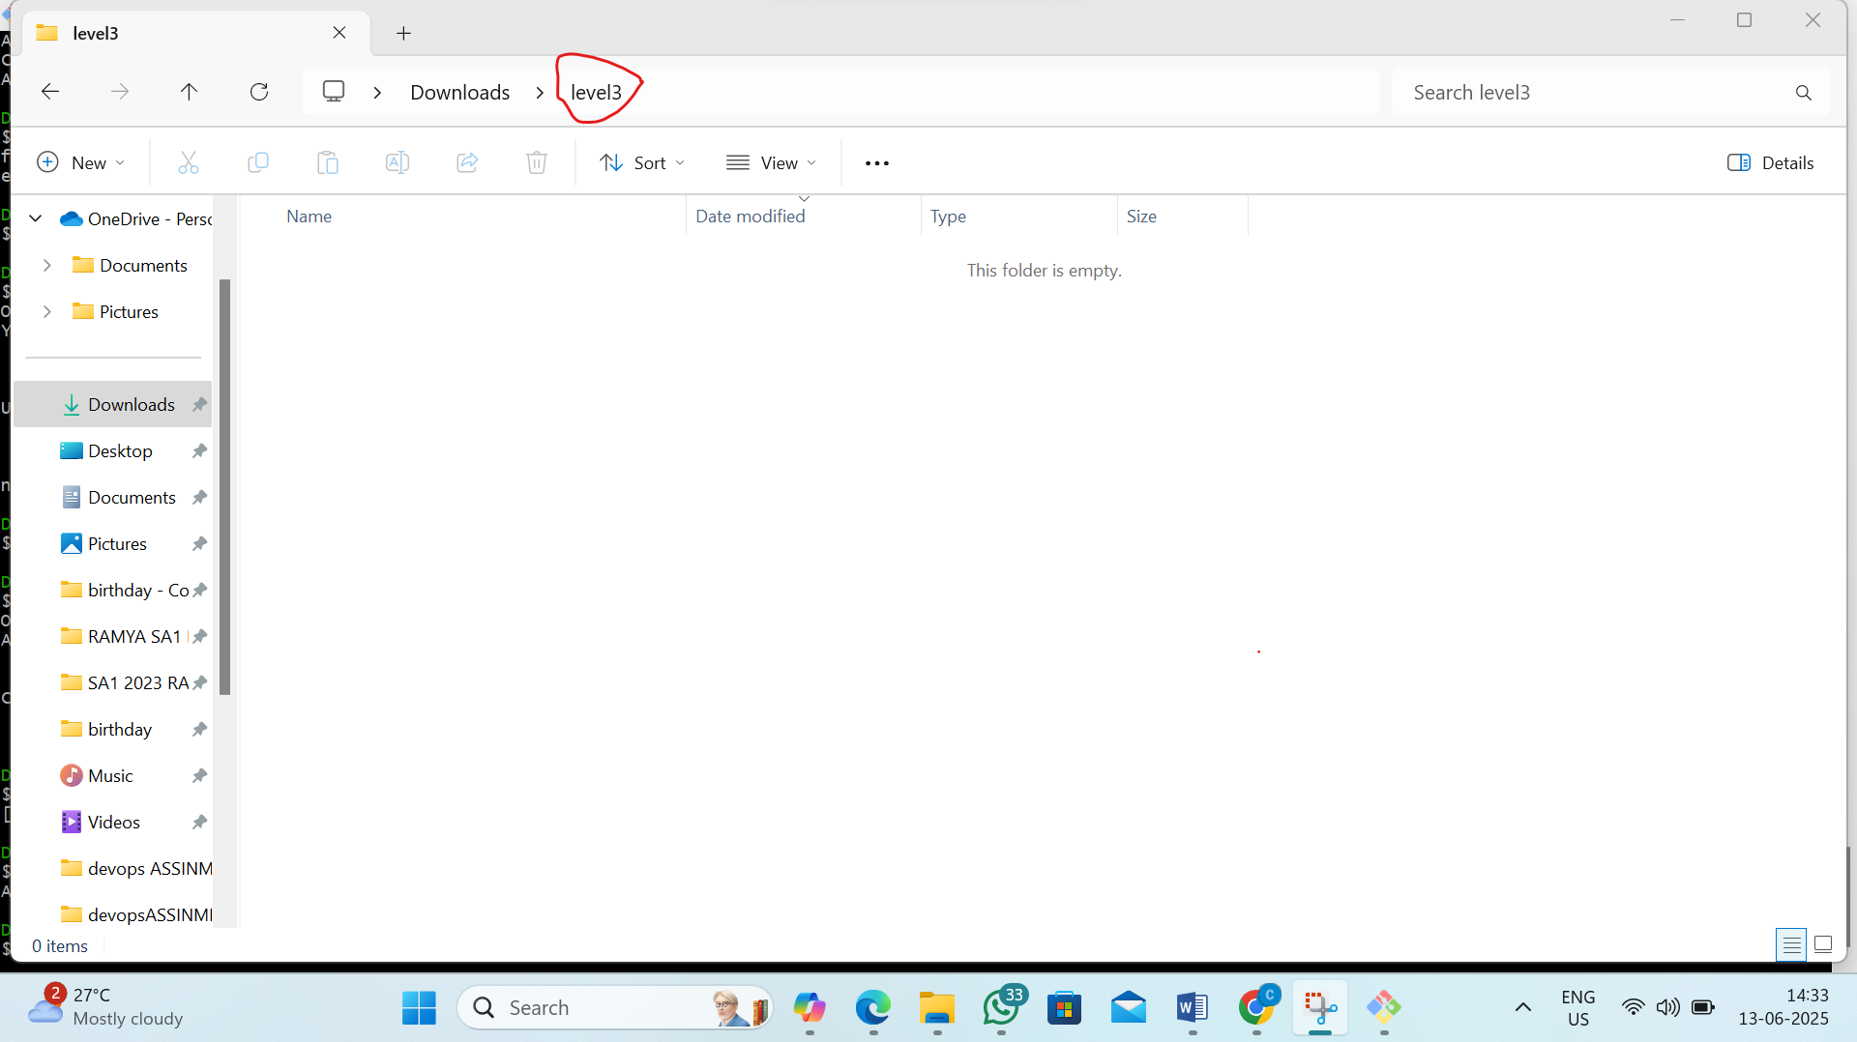

Step3 :open the gitbash and Clone the Remote Repo to Your Local System
By the command:-git clone https://github.com/ChandanYadavKS/level3.git
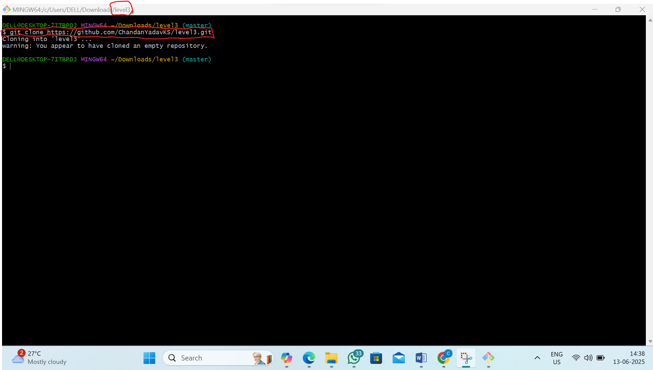
Step 5: Simulate Remote Changes
1)create new file in git hub (in levlel3 repository)
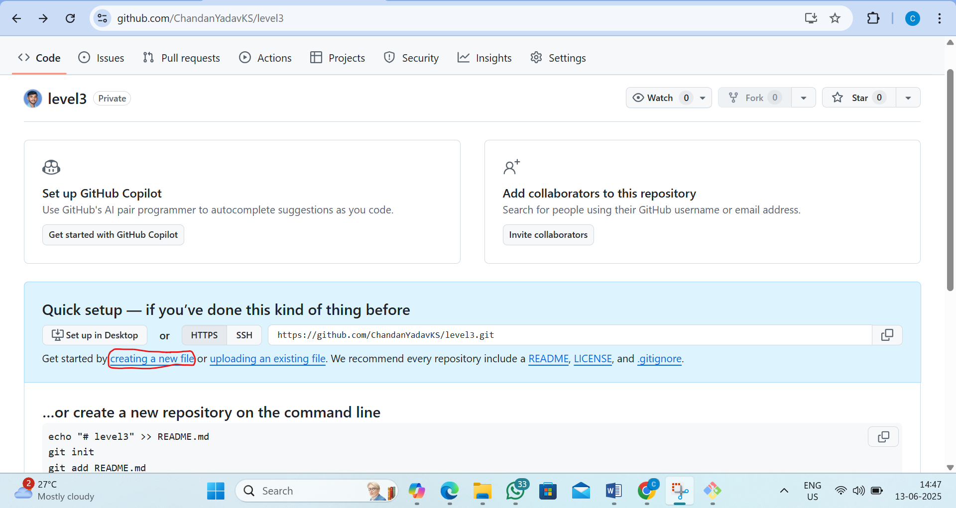

2) Name as remote.txt and inside the file type “this is remote change”
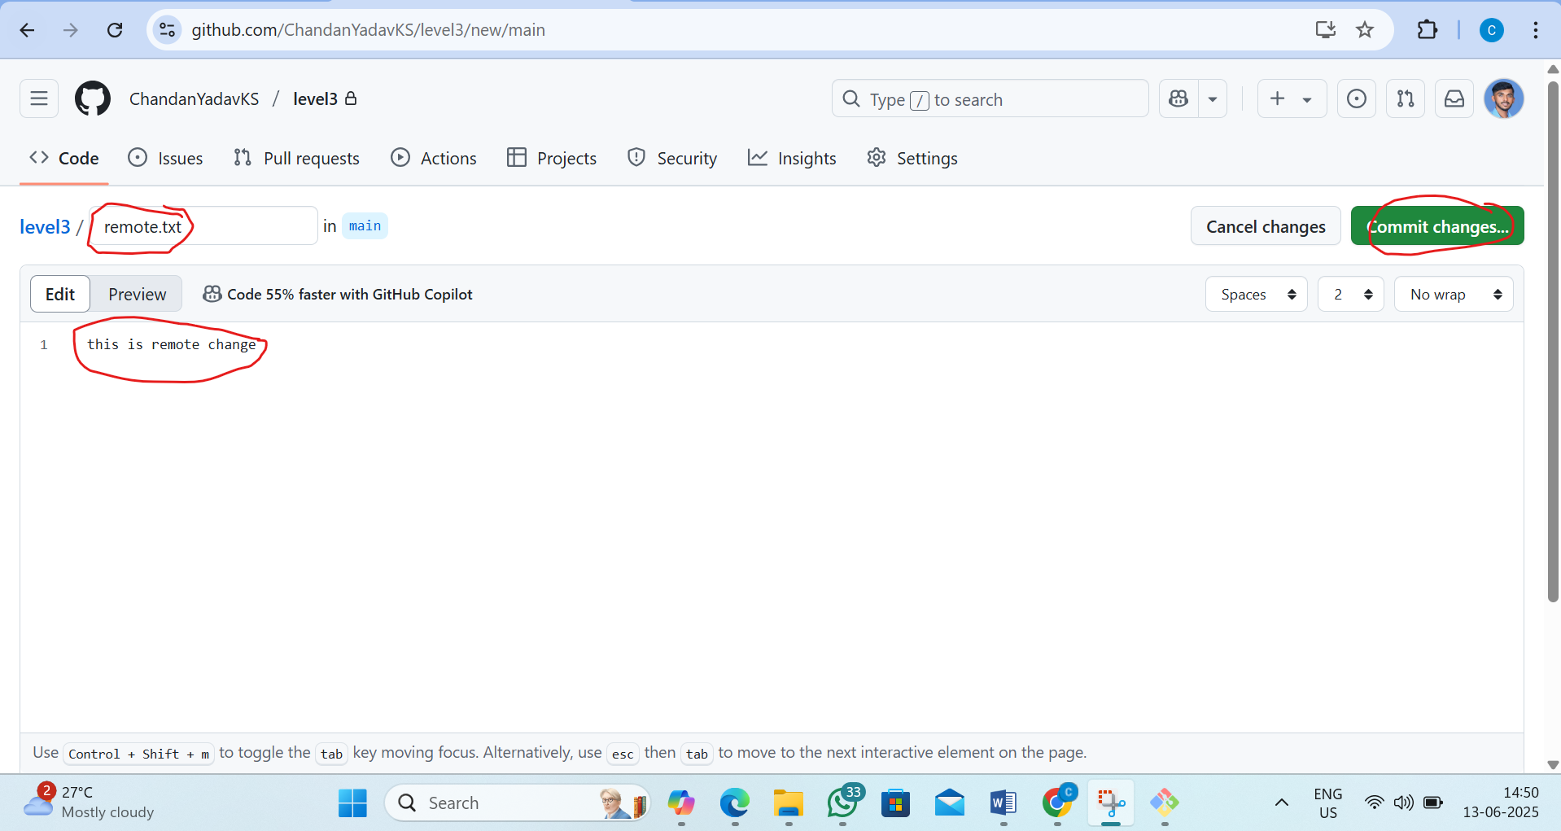
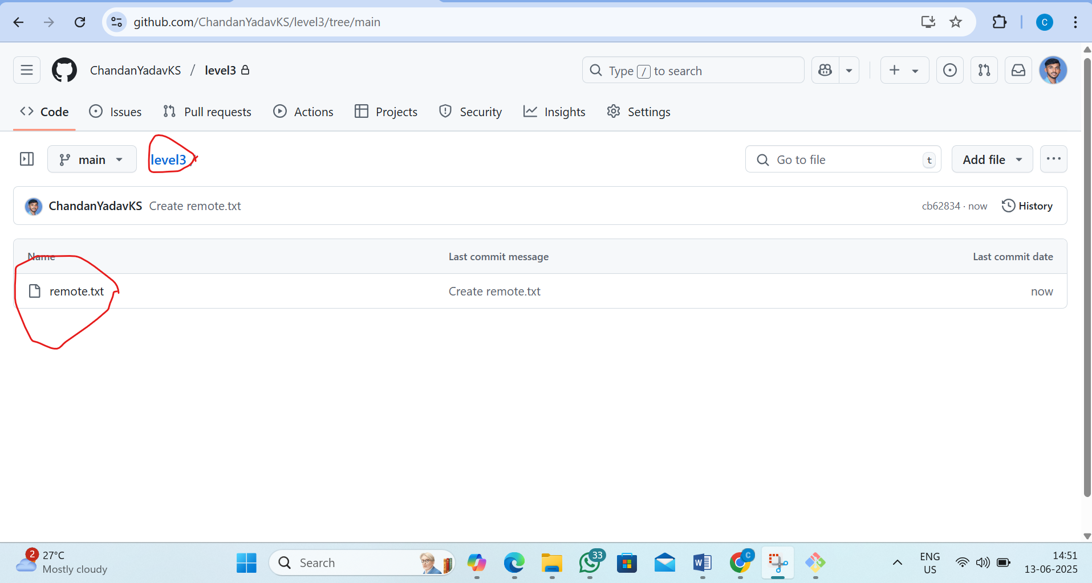
Step 4: Understand git fetch
1) Now, come back to your local Git terminal
pass the command: git fetch
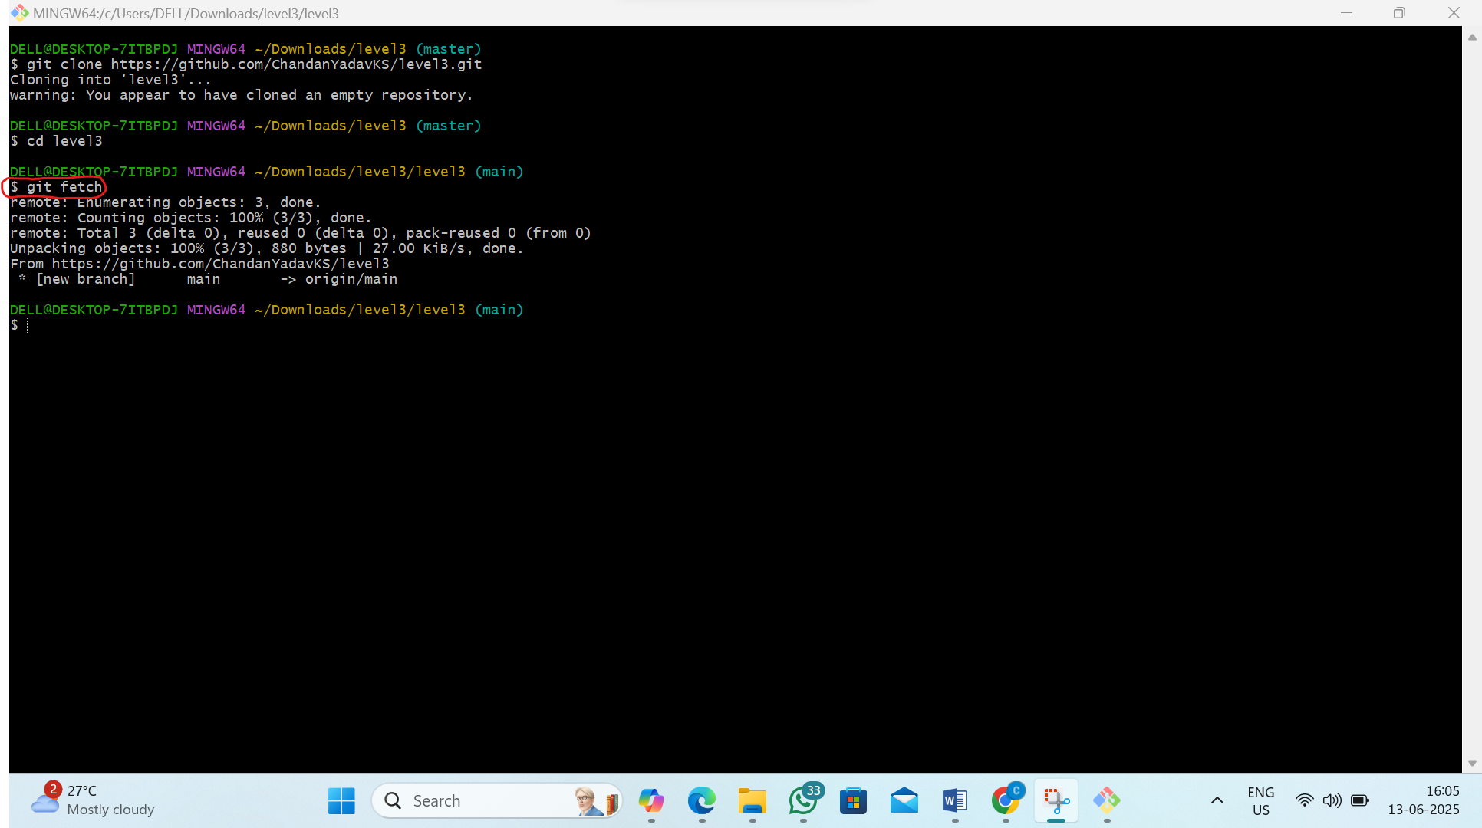
2) To see what was fetched
pass the command: git log origin/main
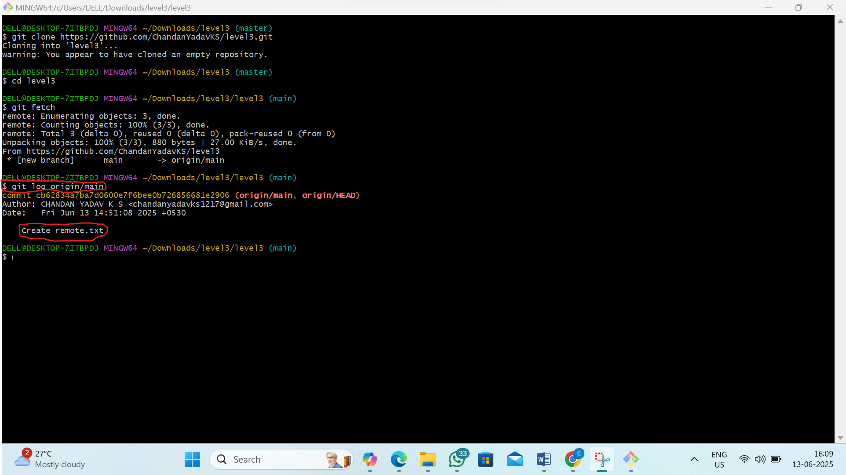

3)now manually merge them into your current branch
by the command:git merge origin/main
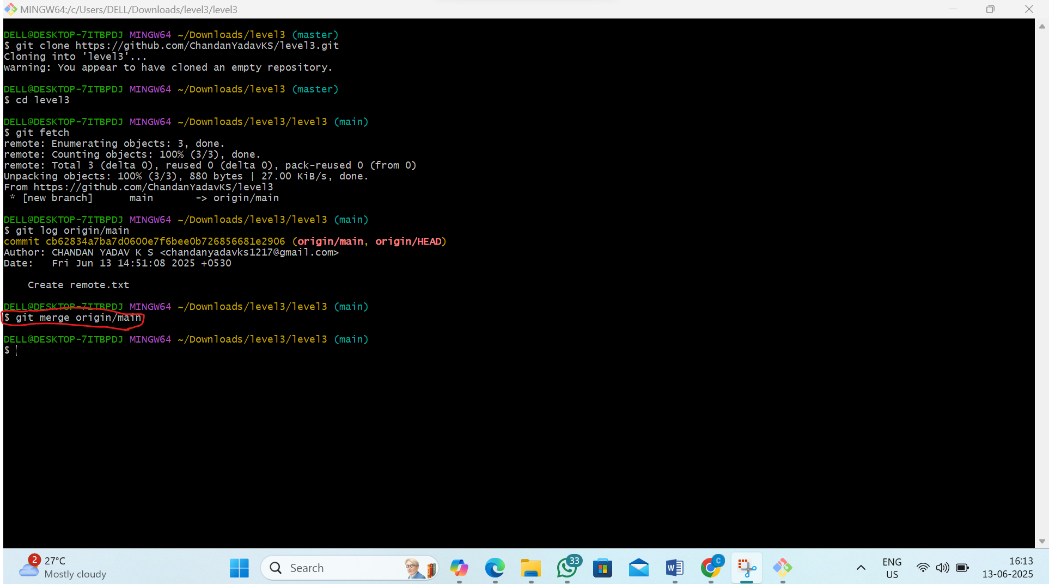

Step 5: Understand git pull
1)create the new file in github repository
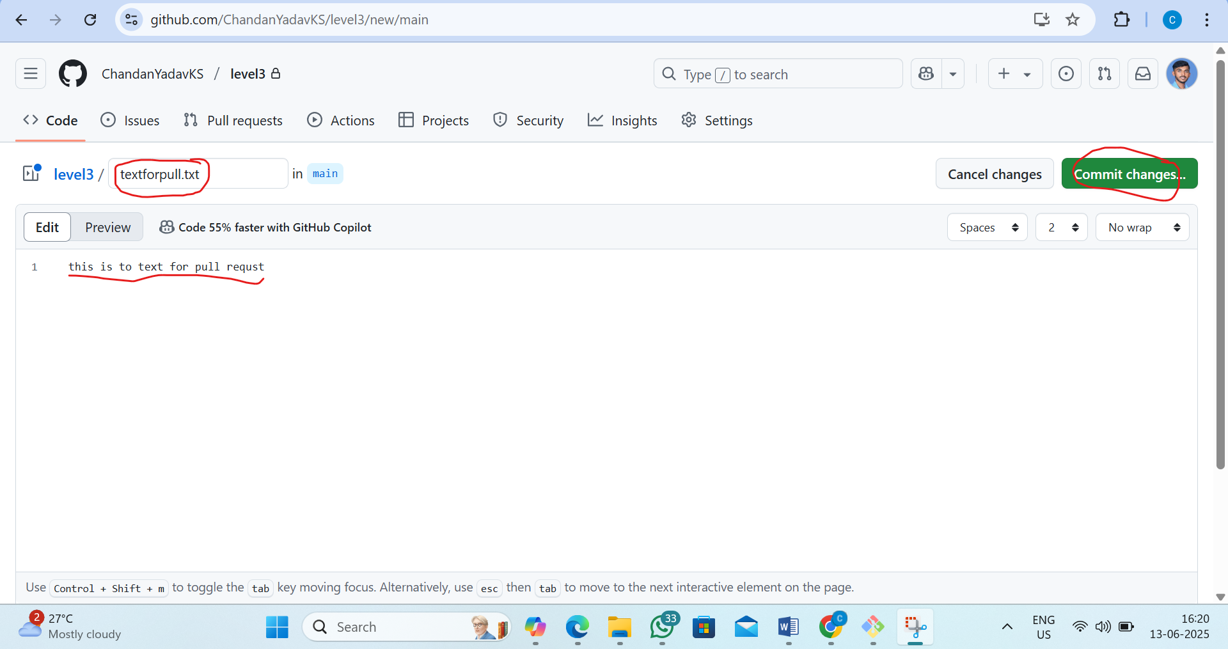

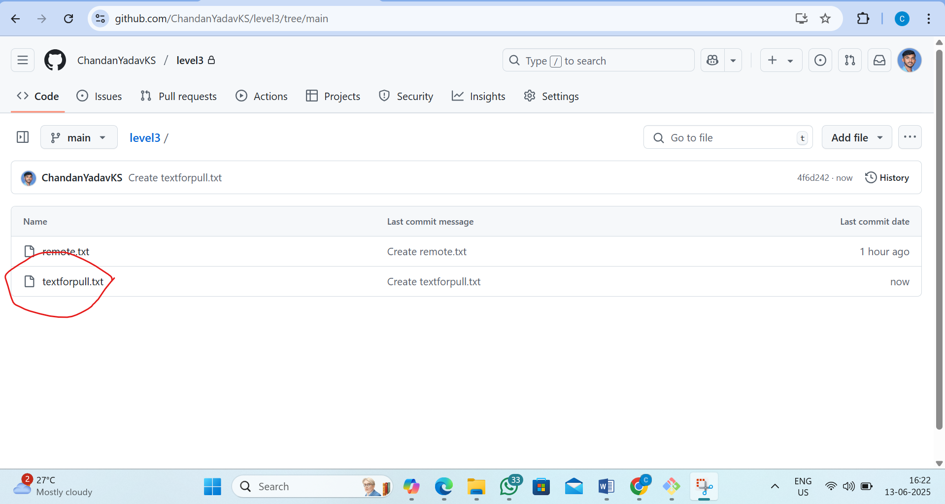

2)now come to local terminal try get pull command
by command:git pull
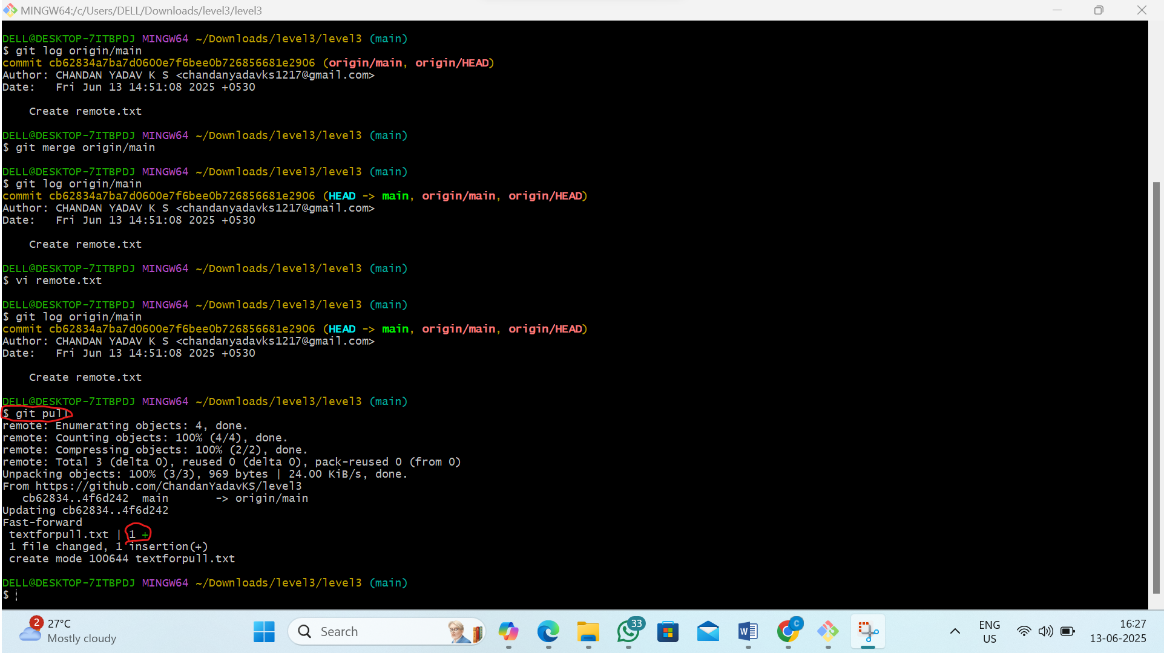

3)now see what was fetched
pass the command: git log origin/main
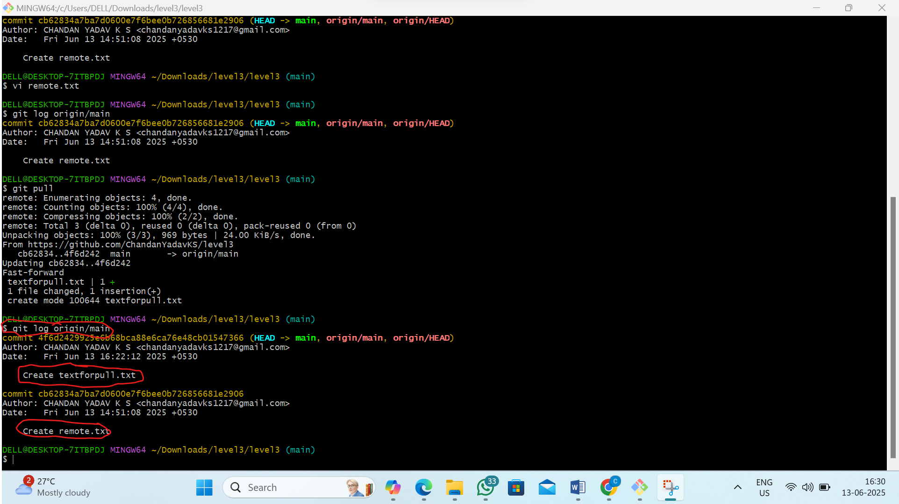

L4 - Clone GitHub repository using Visual Studio Code IDE
Step 1: Copy the Repository URL from GitHub
1) Go to the repository on GitHub
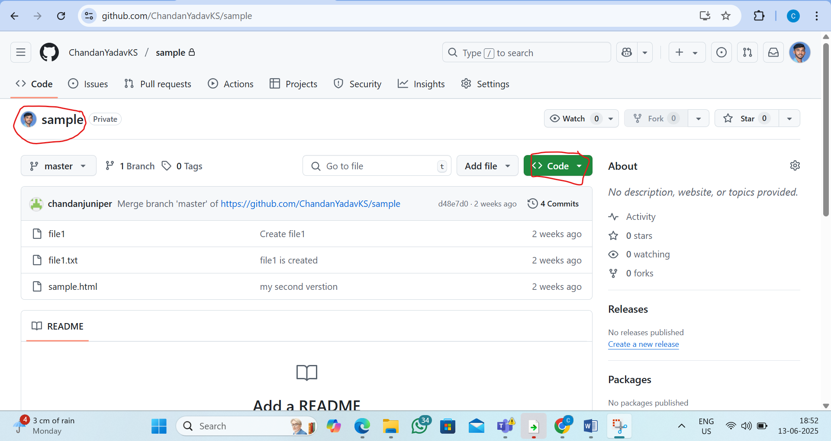
2) Click on the green "Code" button and copy the http url
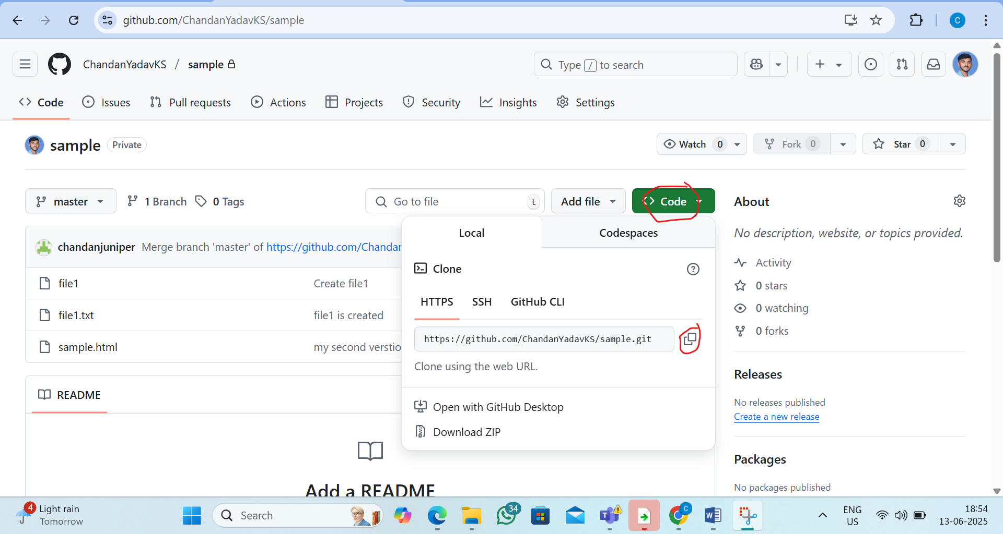

Step 2: Open Visual Studio Code
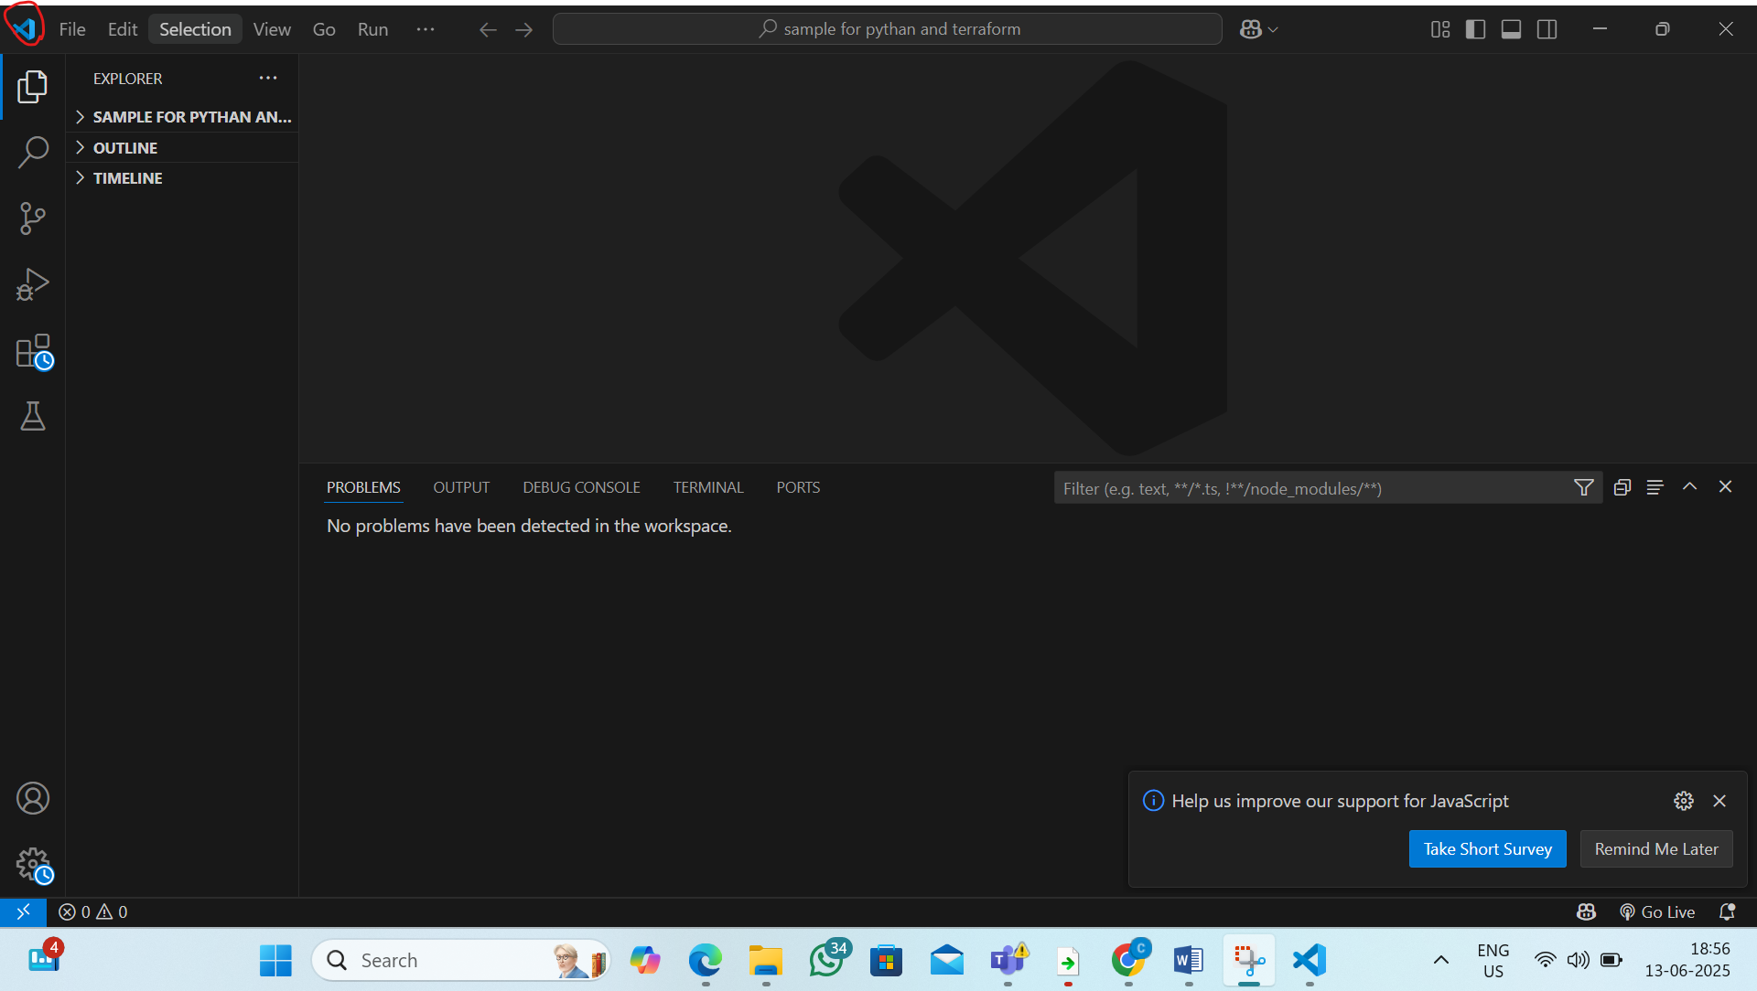
Step 3: Open the Command Palette and type Git: Clone and select it and paste the url of repository
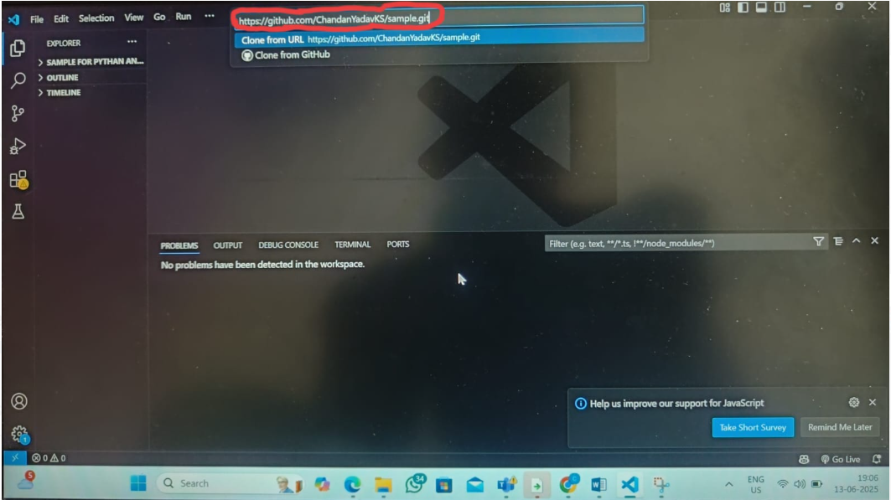

Step 5: Choose Local Folder to Save
1) VS Code will ask where to save the cloned folder
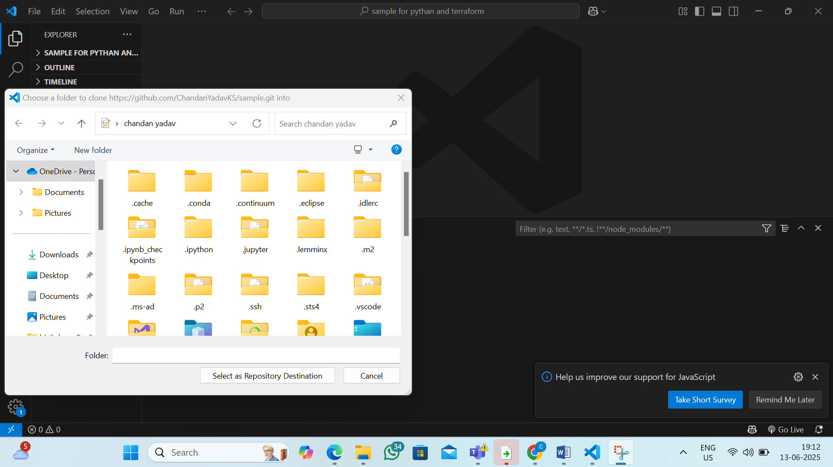

2) create a local folder and It will now clone the repository into that folder
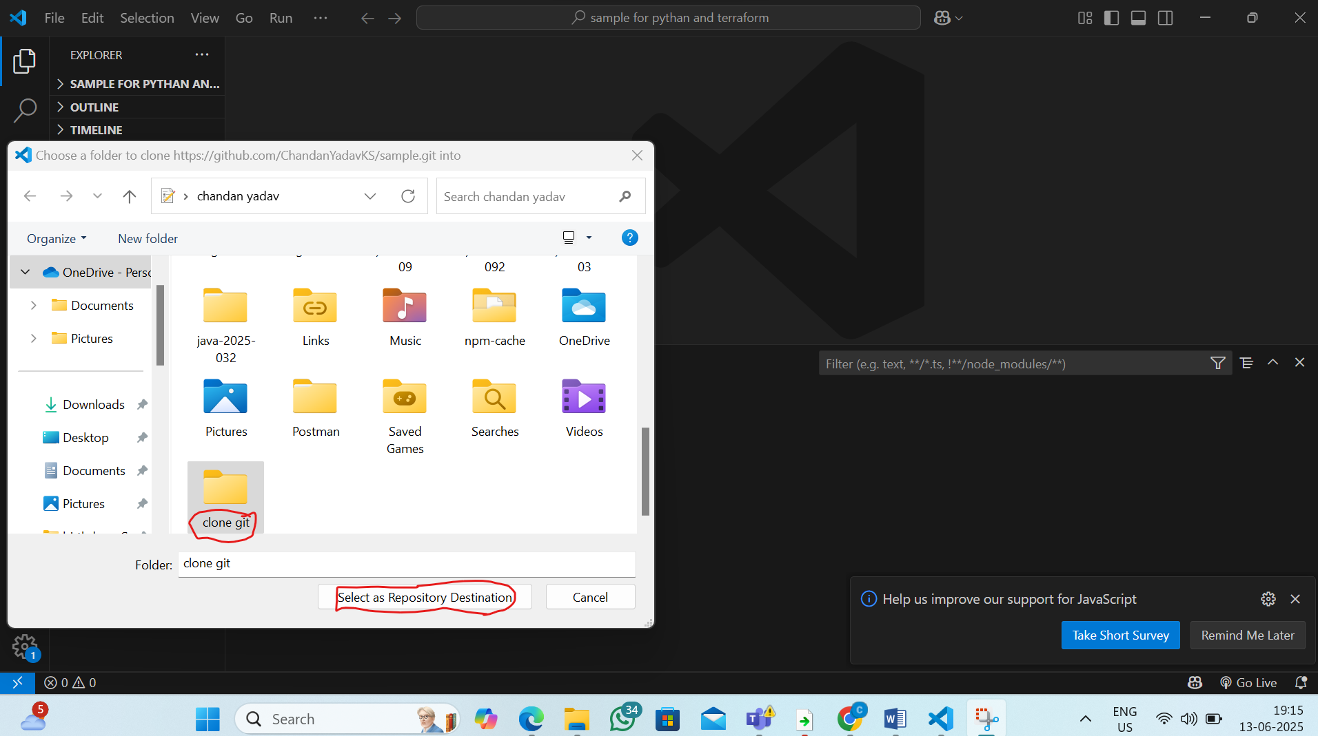

Step 6: Open the Cloned Project
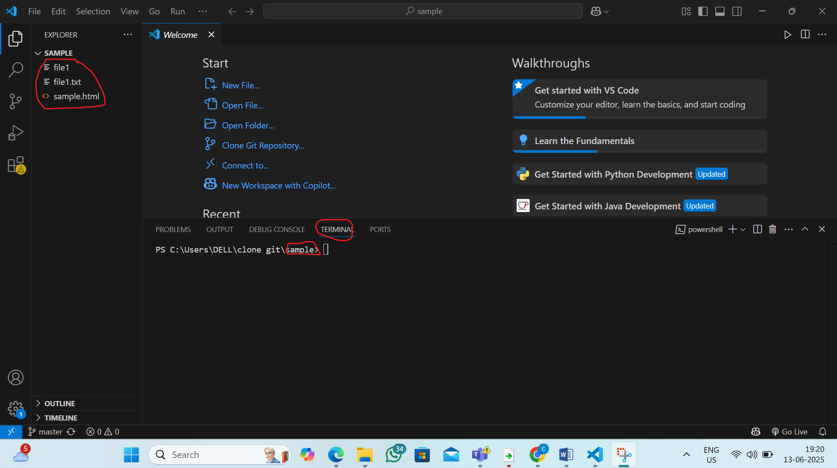

5. L5 - Push the incremental changes to GitHub Repository through Visual Studio Code IDE
Step 1: Make Your Changes in vs code in the cloned repository
1)Add the new file in sample repository
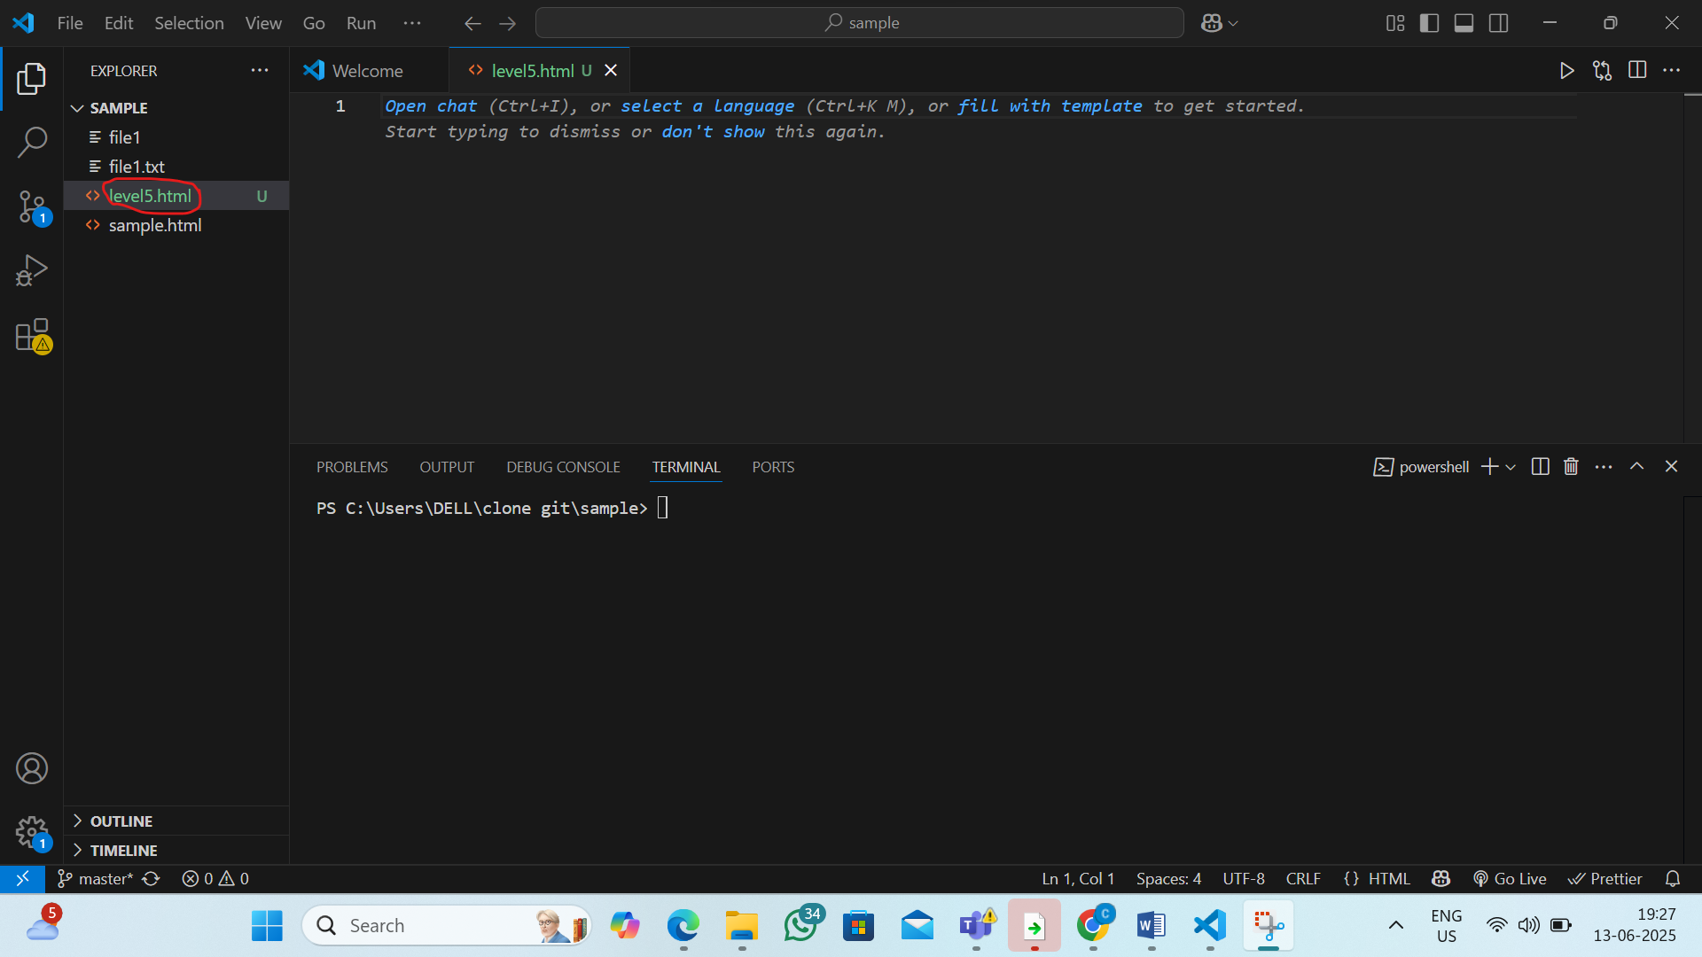
Step 2: Stage the Changes
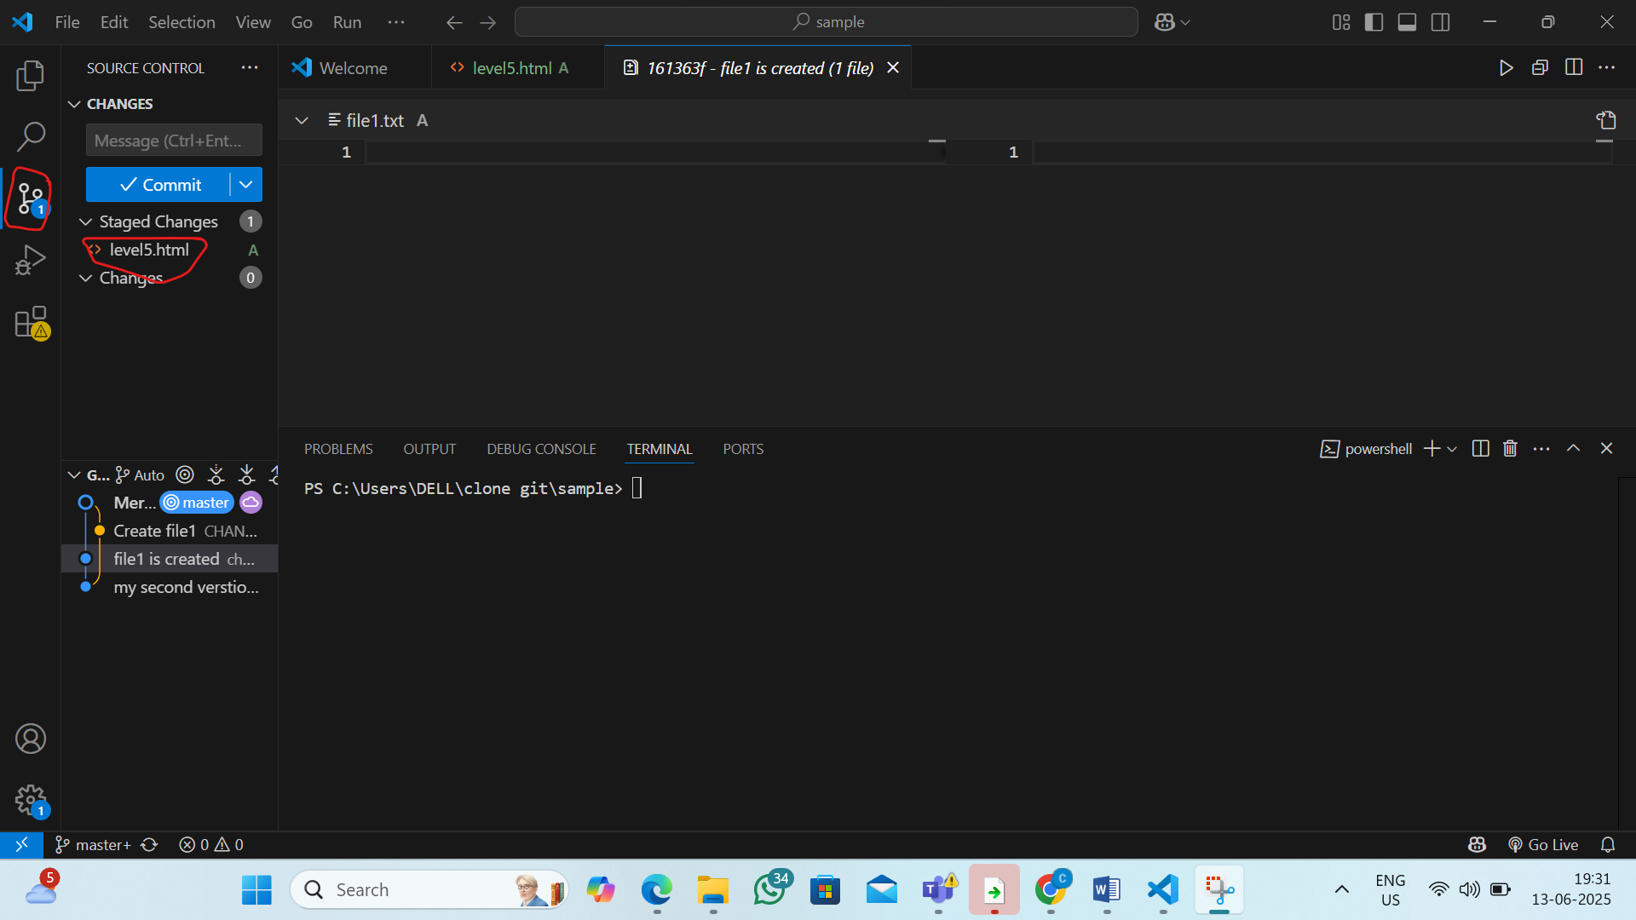

Step 3: Commit the Changes
1) In the message box at the top, enter a commit message
eg:-update level5.html
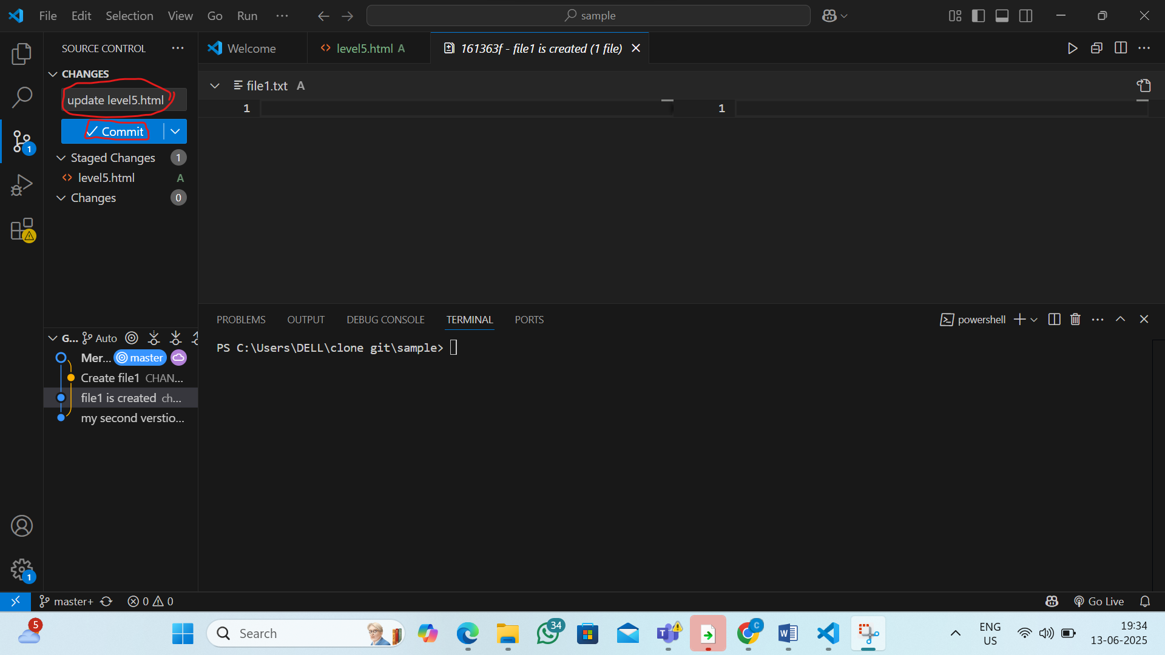

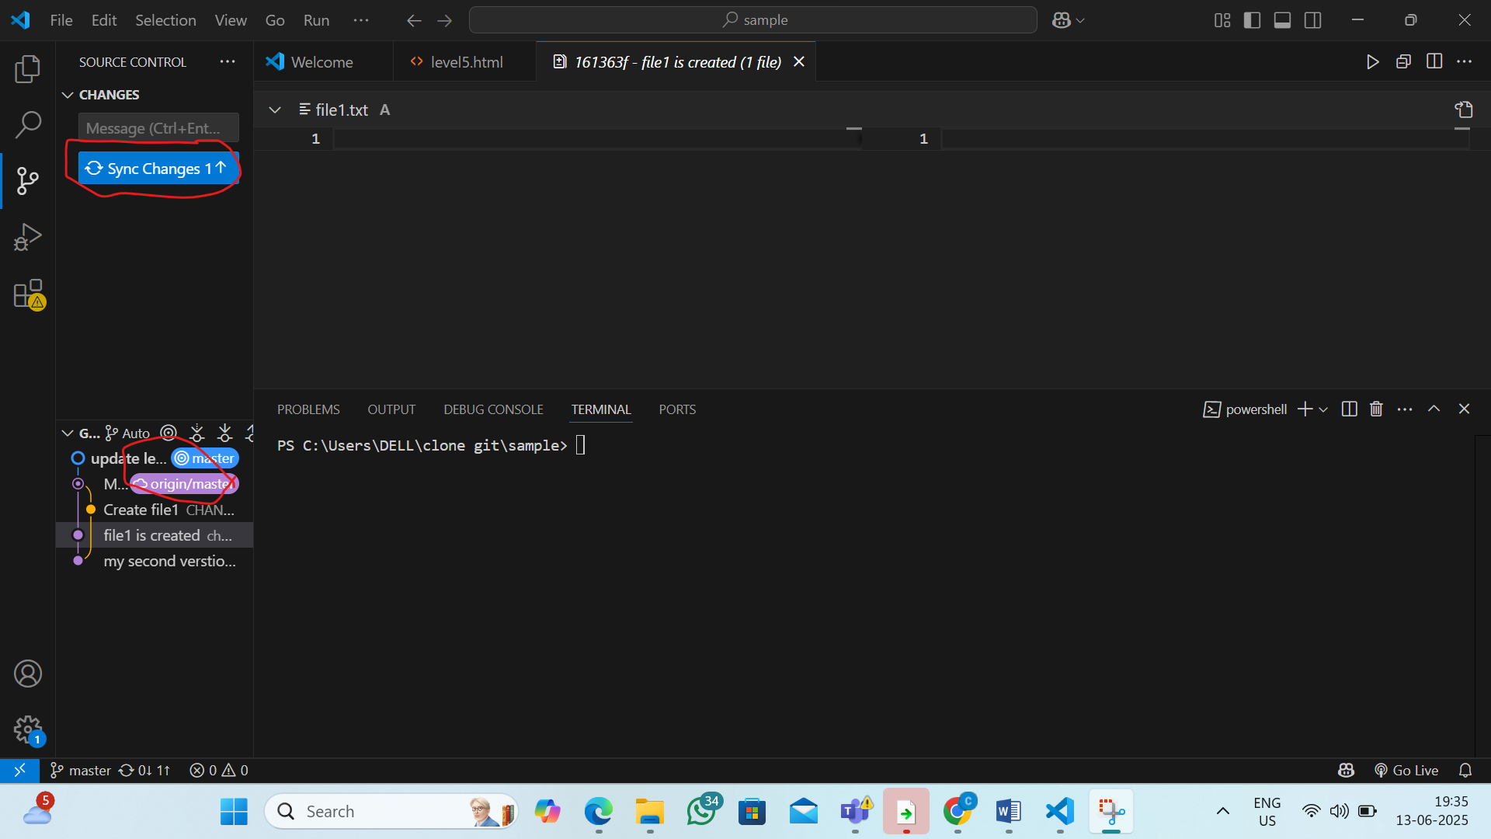

Step 4: Push to GitHub
click 3 dots and click the push
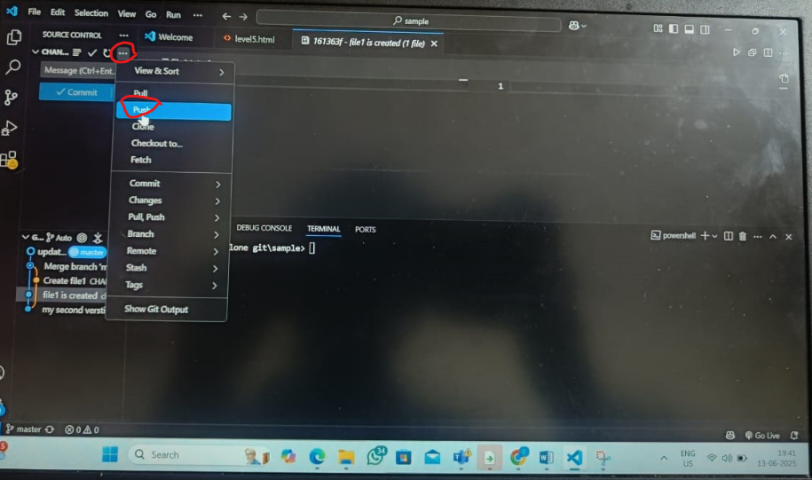

Step5:now in the github repository the level5.html should be add
